**A PROJECT REPORT ON**

**SOUTHERN POWER DISTRIBUTION COMPANY**

**(GSM Based Remote Monitoring and Billing System)**

**Submitted By**

**TEAM AWESOME**

**Aditya M Anand (NEC 09 12 001)**

**Athun V M (NEC 09 12 016)**

**Gayathri M (NEC0912027)**

**Jeevanandam (NEC0912031)**

**Jishnunand PK (NEC0912032)**

**Manoj S Mali (NEC0912037)**

**June 2015**

**Submitted in the fulfillment of the requirements of the Award of**

**Diploma in Information Technology**



**NETTUR TECHNICAL TRANING FOUNDATION**

**#40/40A, Electronic City,**

**Hosur Road, Bangalore-560 100**



**NETTUR TECHNICAL TRANING FOUNDATION**

**#40/40A, Electronic City,**

**Hosur Road,**

**Bangalore-560 100**

**CERTIFICATE**

This is to certify that the project work titled “**SOUTHERN POWER DISTRIBUTION COMPANY**” has been successfully completed in the fulfillment of the award of Diploma in Information technology offered by NTTF during the academic year 2012-2015 and that this report is documentation of the same.

Project Guide Course In-charge Principal

Examiners

Name of the Examiner Signature with Date

1.

2.

**SYNOPSIS**

**Introduction:**

The idea of the developing the application is to provide support for the new post-paid meters, managed remotely by SMS base on GSM.

This application also provides a facility for the customers like online bill payment.

It is particularly applicable for developing and underdeveloped countries where such a post-payment solution may be desirable.

It can solve all the standard business problems existing in operation and maintenance of utilities that use a post payment system.

**ACKNOWLEDGEMENT**

An endeavor of this magnitude is never accomplished in isolation. We are deeply indebted to a number of people notably:

First of all we are thanked to **Mr. Suresh N**, Principal NTTF Training Center NEC-Bangalore, and **Mr. Jagadish G K**, Vice-Principal NTTF Training Center NEC-Bangalore for being a source of inspiration throughout our project.

We owe great to **Mr. Ramakrishnanand**, Course-In Charge in the project work.

We are indebted and grateful to **Mrs. Chitra Devi**, Our Project-In Charge, **Mrs.** **Rijina P**, Our Year-In Charge, **Mrs. Prabha**, Our Project guide, and **Mr. Sreedhar**, Our Subject-In Charge, guide for valuable guidance at each and every stage of our project.

With deep sense if gratitude we express our heartfelt thanks to Mrs. Deepa, Mrs. Soumya, Ms. Swathi and all other staff members who gave valuable suggestions and constant encouragement for successful fulfillment of the project.

Finally we thank one and all who had helped us directly and indirectly for the completion of the project.

**CONTENTS**

1. **Introduction**
   1. Title of the project
   2. Group Name
   3. Group Leader
   4. Group Members
   5. S/W & H/W Configuration
   6. Technology used
   7. Project Description
   8. Project Modules
   9. Project Plan
2. **SRS Document**
3. **System Design**
   1. Control Flow Diagram
   2. Data Flow Diagram
   3. Entity Relationship Diagram
   4. Use Case Diagram
   5. Database Design
   6. Data Dictionary
   7. Gantt Chart
4. **Snapshots**
5. **Source Code**
6. **Reports, Test plan, Test case, Bug Report**
7. **Future Enhancements of Project**
8. **Bibliography**
9. **Conclusion**

**1.1 TITLE OF THE PROJECT :** SOUTHERN POWER DISTRIBUTION COMPANY

**1.2 GROUP NAME : TEAM AWESOME**

**1.3 GROUP LEADER :** Aditya M Anand (NEC 09 12 001)

**1.4 GROUP MEMBERS:**

Athun VM (NEC0912016)

Gayathri M (NEC0912027)

Jeevanandam (NEC0912031)

Jishnunand PK (NEC0912032)

Manoj S Mali (NEC0912037)

**1.5 S/W & H/W CONFIGURATION**

**SOFTWARE REQUIREMENTS:**

Front End 🡪 JSP, HTML5, CSS

Database 🡪 MySQL 5.6

Scripting language 🡪 Jquery, Bootstrap

Web Server 🡪 Apache Tomcat Server6.0

Operating System 🡪 Windows 7 +

IDE 🡪 Eclipse with my Eclipse plug-ins,

Sublimetext3

Third Party Software 🡪 Ozeking SMS Gateway

Social Services 🡪 Gmail Services for sending mail

Browsers 🡪 IE8/8+, Chrome15+,Safari 4+,Mozilla Firefox

**HARDWARE REQUIIREMENTS:**

Processor : Pentium IV and above

RAM : 512 MB

Hard Disk : 80 GB

**1.6 TECHNOLOGY USED**

J2EE, JSP, HTML5, MYSQL 5.6.25.0

**1.7 PROJECT DESCRIPTION**

The objective of this project is to replace the existing manual reading of electricity meters installed throughout the country (Home, Agricultural, and Industrial).

The proposed solution is to build a server for the Electricity boards in each state where the custom built GSM meters would update in real time through SMS.

**1.8 PROJECT MODULES**

The modules present in SOUTHERN POWER DISTRIBUTION COMPANY are:

Admin:

LOGIN

CREATE/DELETE USER

GENERATE BILLS

SEND SMS TO CLIENTS

SEND AKNOWLEDGEMENT TO USERS

VIEW CLIENT QUERIES

SEND RESPONSE TO CLIENT QUERIES

PAYMENT

LOG OUT

User:

LOGIN

VIEW BILLS

CUSTOMER DETAILS

PAYMENT

FEEDBACK/COMPLAINTS

LOG OUT

**Module Description:**

1. ADMIN MODULE:

* The admin can login by entering their admin-id and password.
* The admin can create and delete accounts if they wish to.
* The admin can maintain the GSM device.
* Generates the bill for different users.
* Sends SMS to all devices.
* Sends acknowledgements to users.
* The admin can view the client queries.
* The admin can send response to client queries.
* Payment of bills.

1. USER MODULE:

* The user can login using his/her account.
* The user can view the bills.
* The user can view his/her personal details.
* Payment of bills.
* The user can send feedback or even complaints to the admin.

**JSP:**

* JSP pages are components in a web or J2EE application that consists of HTML and Java code
* Code in a JSP can access data across the entire web application and can use server-side resources such as databases, directories, and other application components.
* JSP pages are dynamic because they can contain Java code, which can process the request and tailor the response based on the request. All the power of Java sits behind every JSP page.
* Jsp is easy to learn and allows developers to quickly produce websites and application in an open and standard way. Jsp is based on java, an object oriented language. Jsp offers a robust platform for web development.

Main reasons to use Jsp:

1. Multi-Platform.
2. Component reuse by using JavaBeans and EJB.
3. Advantages of java.

**MySQL:**

MySql is a database which helps us to store data in large amount and retrieve when required. It is majorly used for the server side storage in most of the project which also take cares with the security by login.

This also easy to create, update, delete, insert and perform other operations when required easily. The database created can be easily taken as back up and restored in any place again and executed. Backup of information can be taken in the MySql.

The Oracle relational database management system (RDBMS) provides an open, comprehensive, integrated approach to information management.

This is accomplished while delivering high performance. At the same time, it prevents unauthorized access and provides efficient solutions for failure recovery.

**TESTING:**

Testing must be done with proper planning as the system testing is very expensive for large systems, huge amount has spent for testing.

Test planning is concerned with setting out standards for the testing process, rather than describing product tests. Error may begin to occur the very inspection of the process whether the objectives may be imperfectly specified, as well as later design and development stages.

After the source was ready, the application was tested to uncover as many errors as possible. Tests were conducted to:

* Examine the internal logic of the application components/Elements.
* Examine the input and output domains of the program to Uncover errors in the program functions and performance.

**2. SOFTWARE REQUIREMENT SPECIFICATION (SRS)**

**Advantages of SOUTHERN POWER DISTRIBUTION COMPANY :**

The aim of proposed system is to develop a system of improved facilities. The proposed system can overcome all the limitations of the existing system.

1. It provides an advantage and support the concept of e-governance

in the electric reading and metering.

1. Our system provides the customer precise consumption information.
2. It gives accurate billings.
3. Provides better and fast customer service. It reduces man power and time consumption.

**Purpose:**



**Scope:**

* It is particularly applicable for developing and underdeveloped countries where such a post-payment solution may be desirable.
* It can solve all the standard business problems existing in operation and maintenance of utilities that use a post payment system.

**Functional Requirements:**

1. By Entering the correct credentials and click on the login button user should navigate to home page which contains the links to access the system further.
2. By clicking on the links and tabs the user should navigate to respective page correctly.
3. Users can register to the website by filling a predefined from and while clicking on submit button the details should store to the database used and can be retrieved as when required.
4. In SPDC, users should able to view his previous bills, current bill and payment of bill after login.

**3. SYSTEM DESIGN**

3.1 CONTROL FLOW DIAGRAM (CFD)

USER FUNCTIONALITY

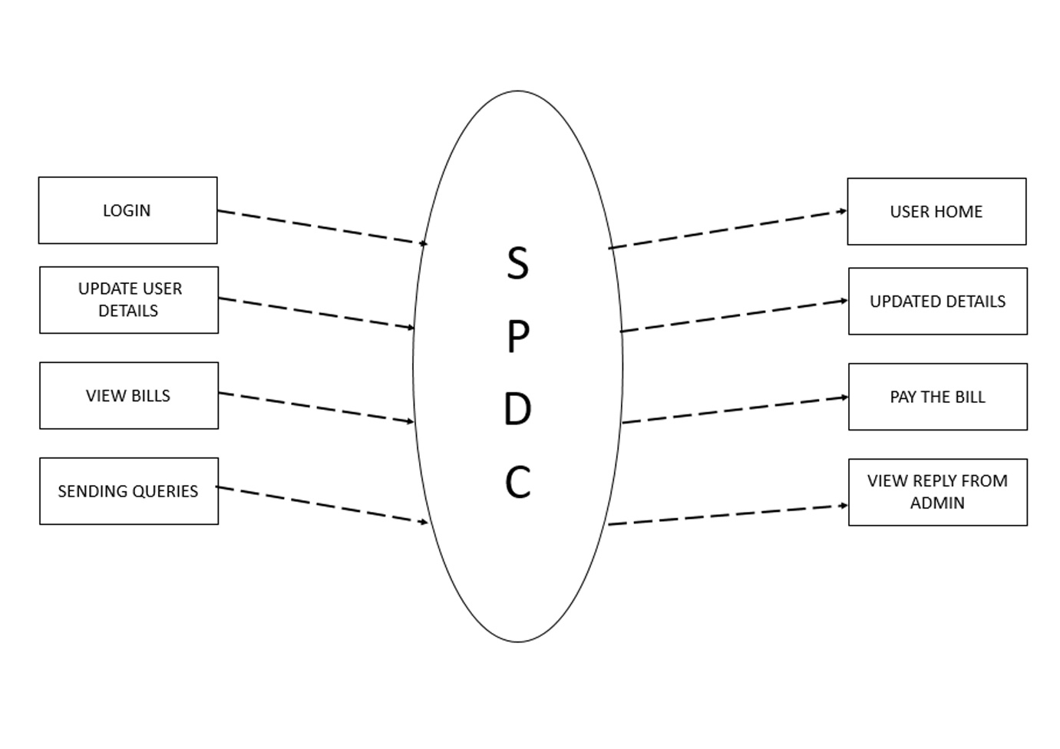

ADMIN FUNCTIONALITY

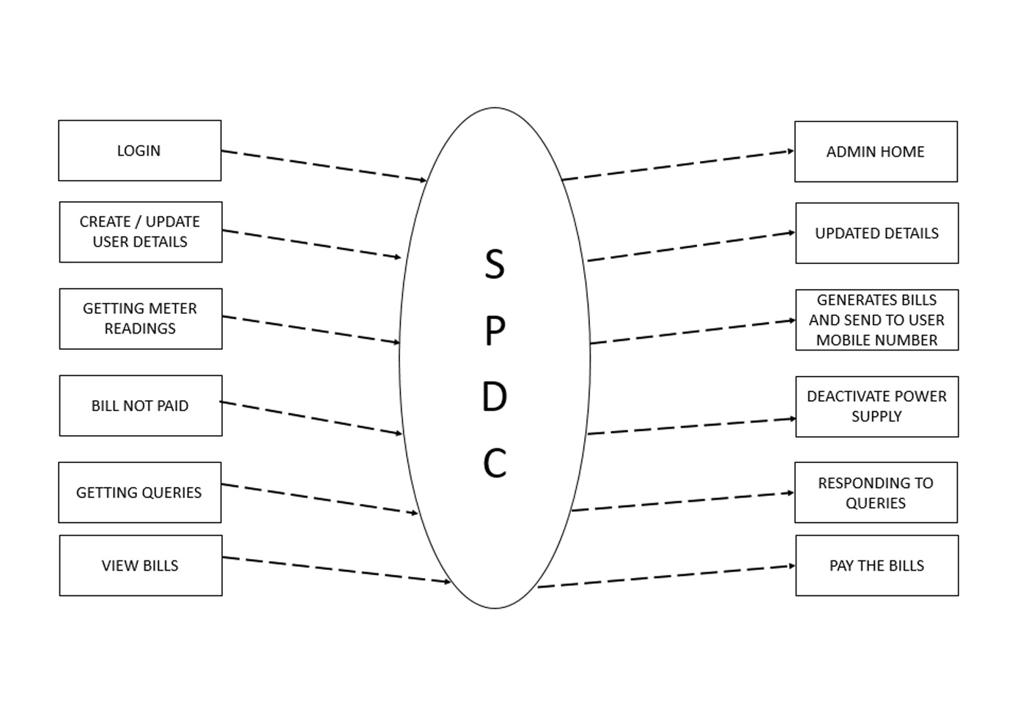

SUPER ADMIN FUNCTIONALITY

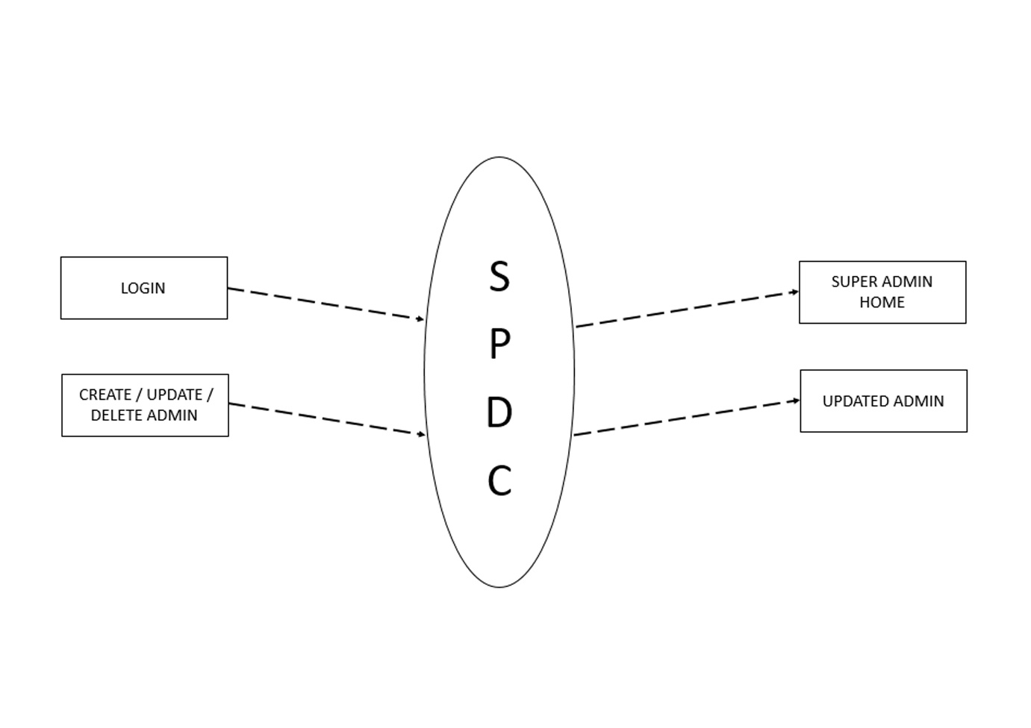

3.2 DATA FLOW DIAGRAM (DFD)

USER DFD

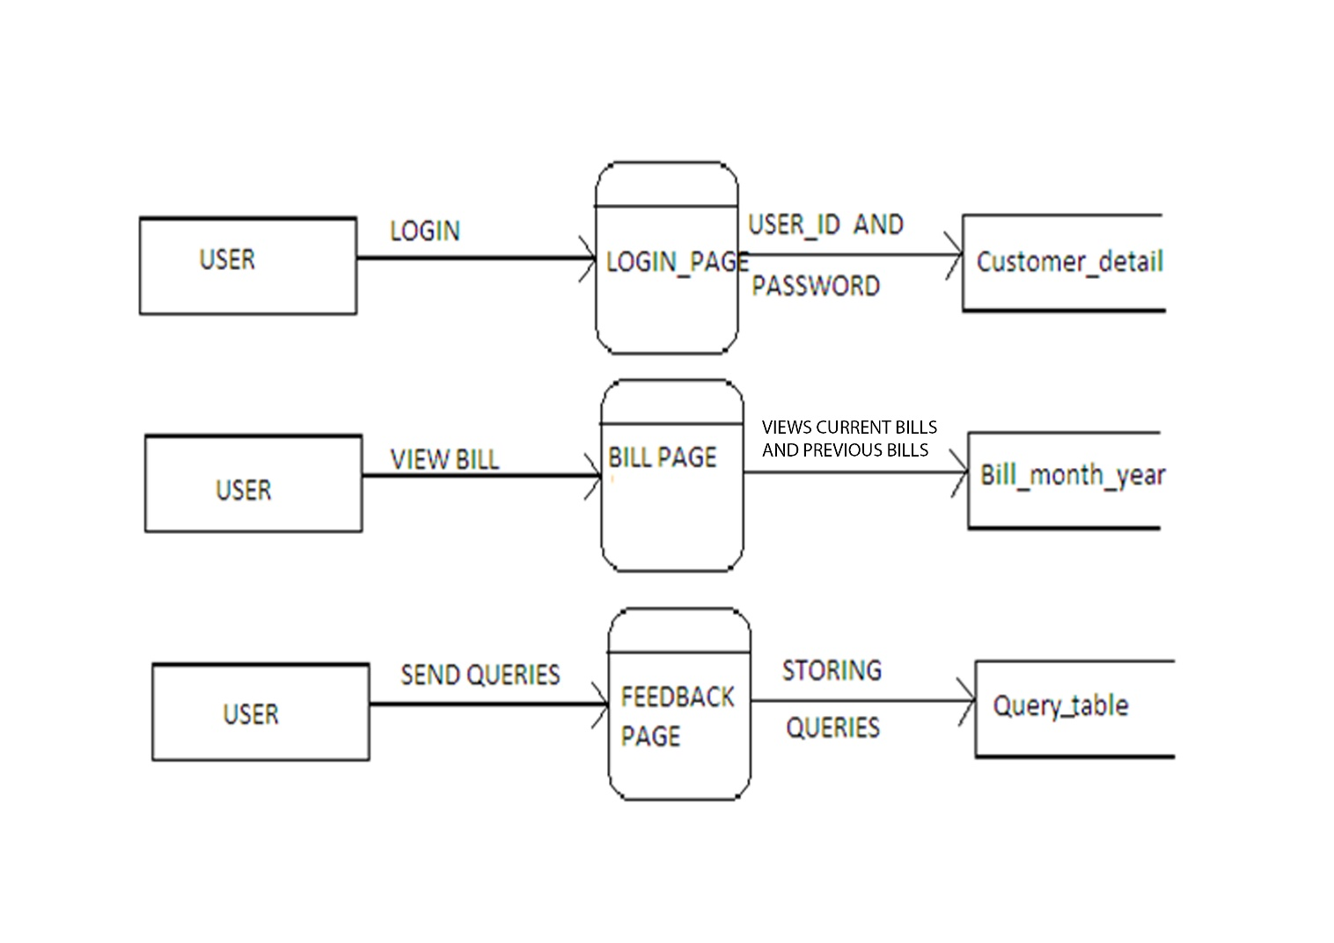

Super Admin DFD

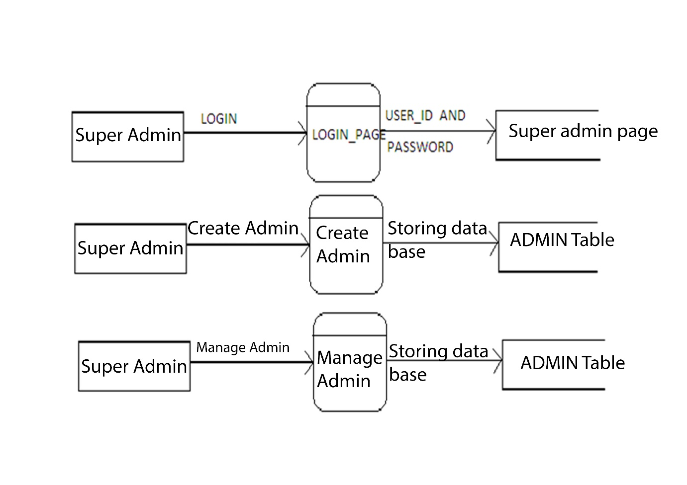

ADMIN DFD

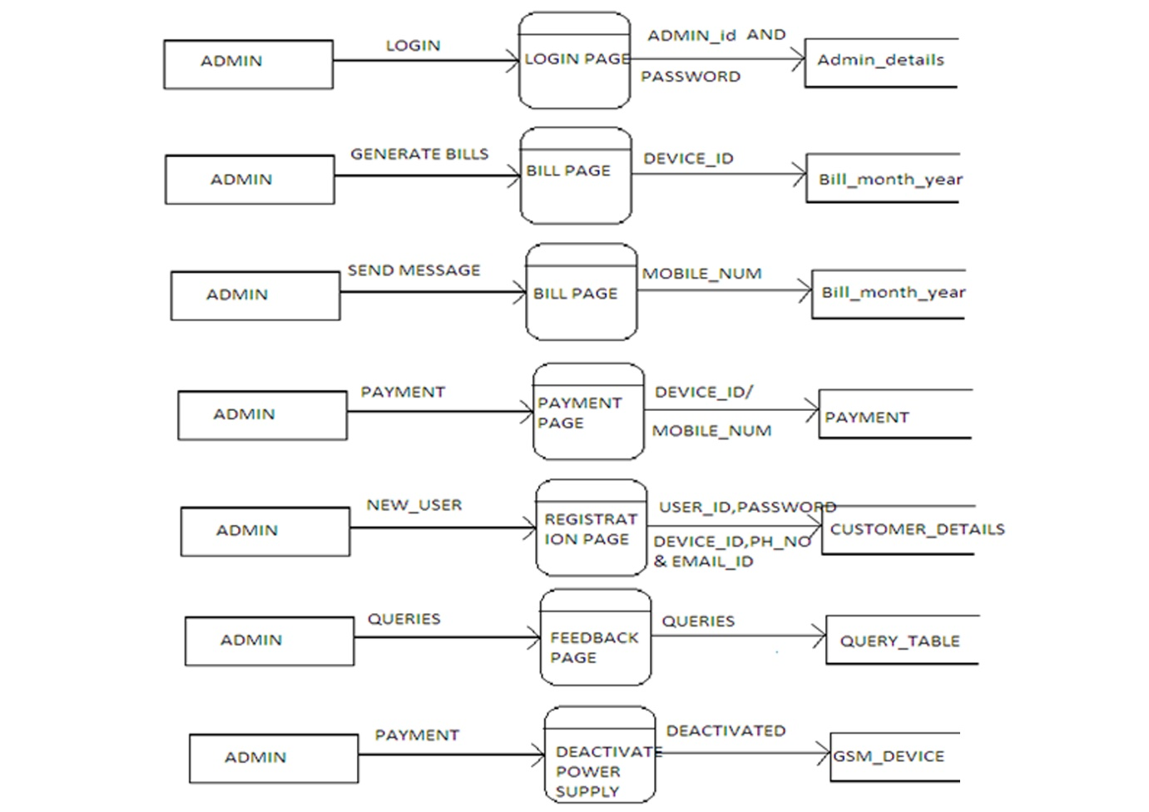

* 1. ENTITY RELATIONSHIP DIAGRAM

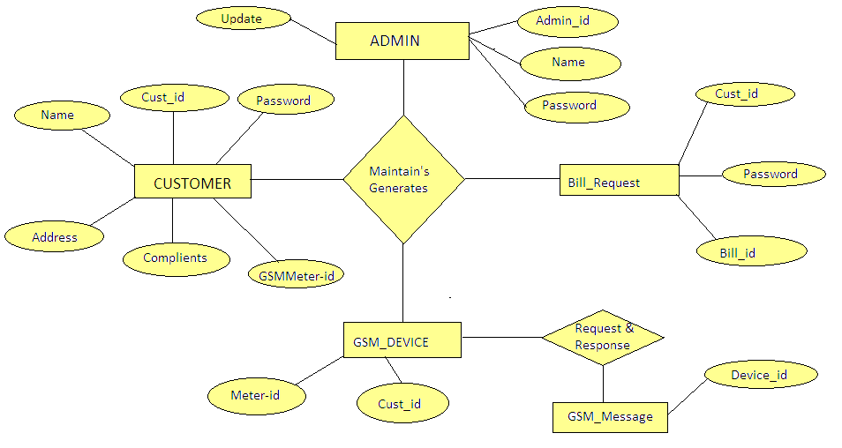

3.4 USE CASE DIAGRAM:

USER DIAGRAM:

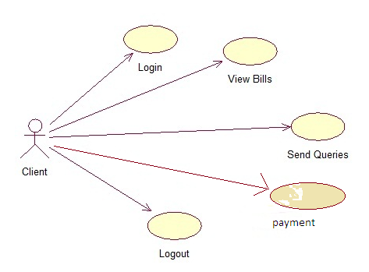

ADMIN DIAGRAM:

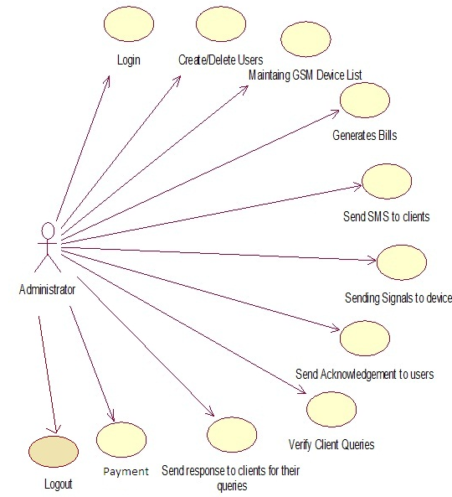

SUPER ADMIN

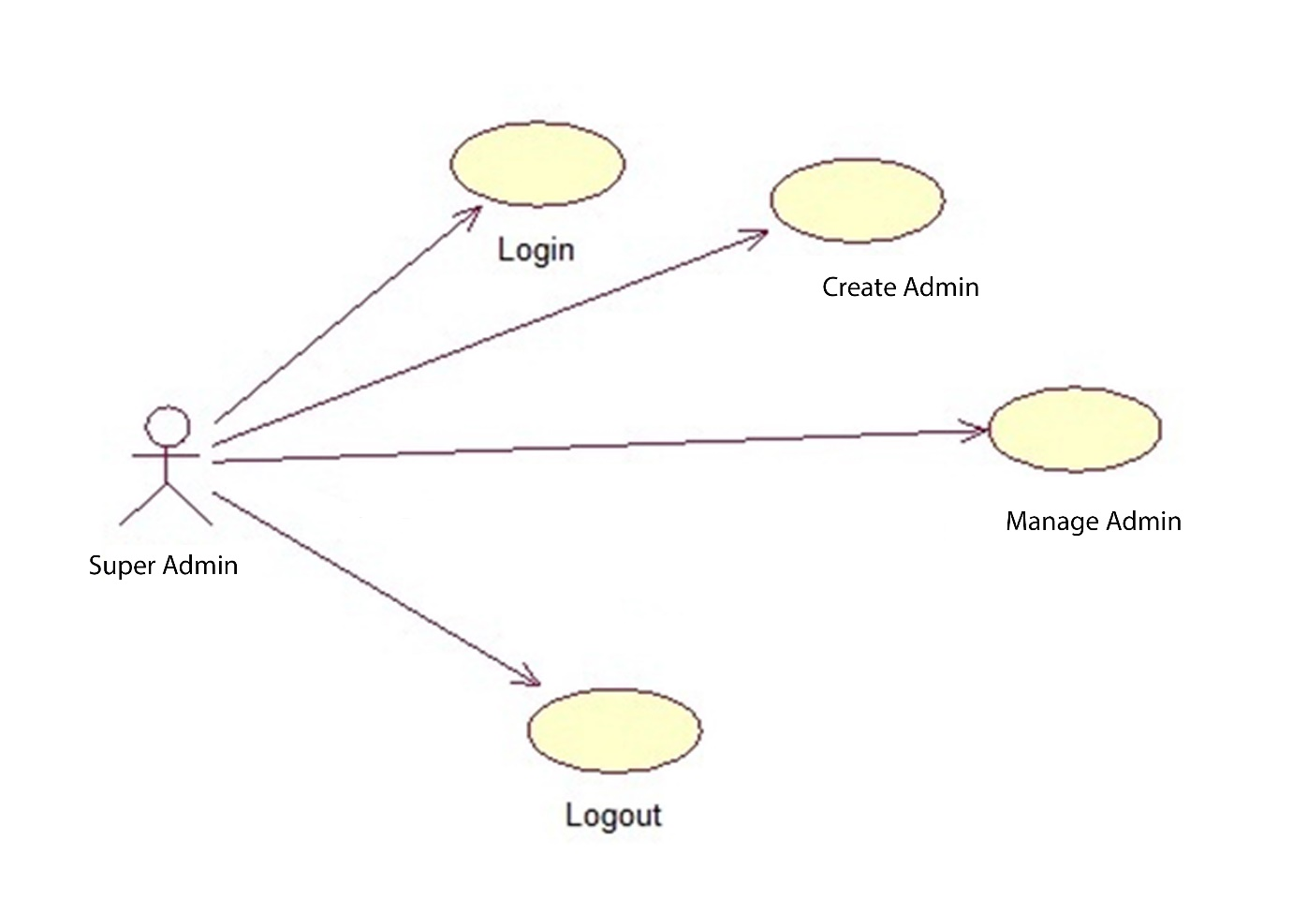

* 1. DATABASE DESIGN

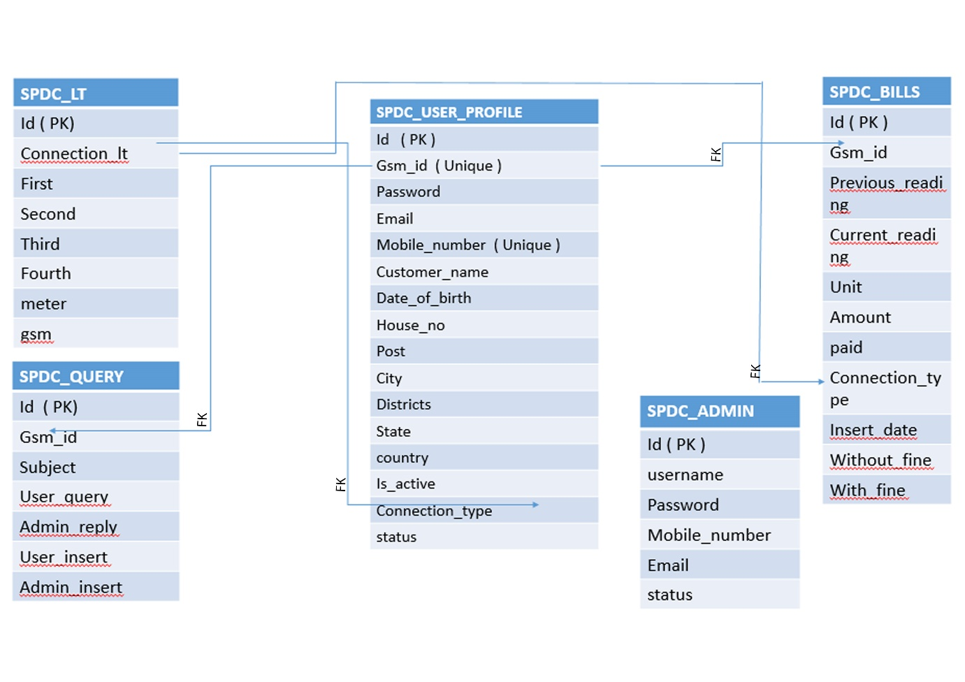

* 1. DATA DICTIONARY

SPDC_LT TABLE

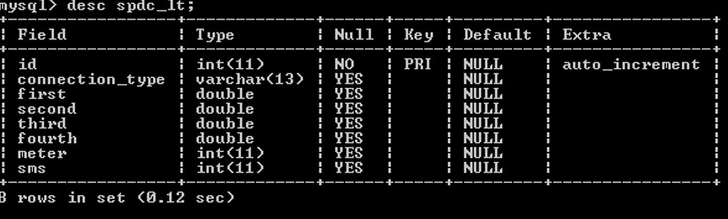

SPDC_USER_PROFILE

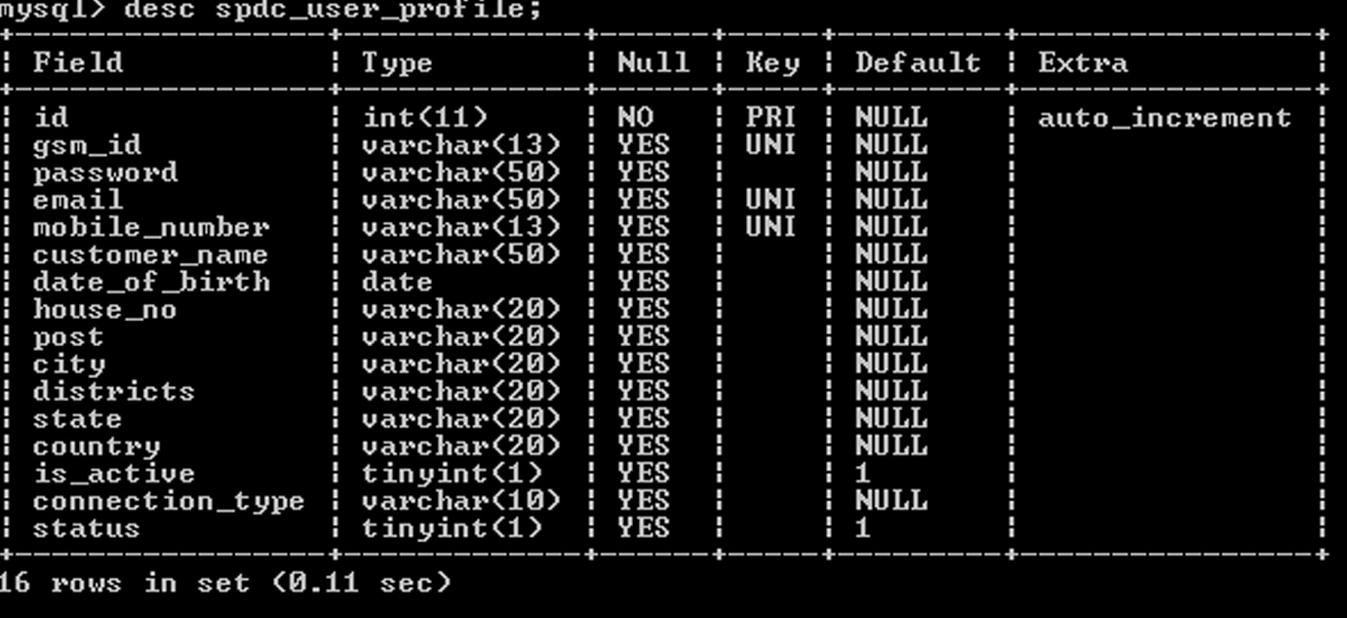

SPDC_BILLS TABLE

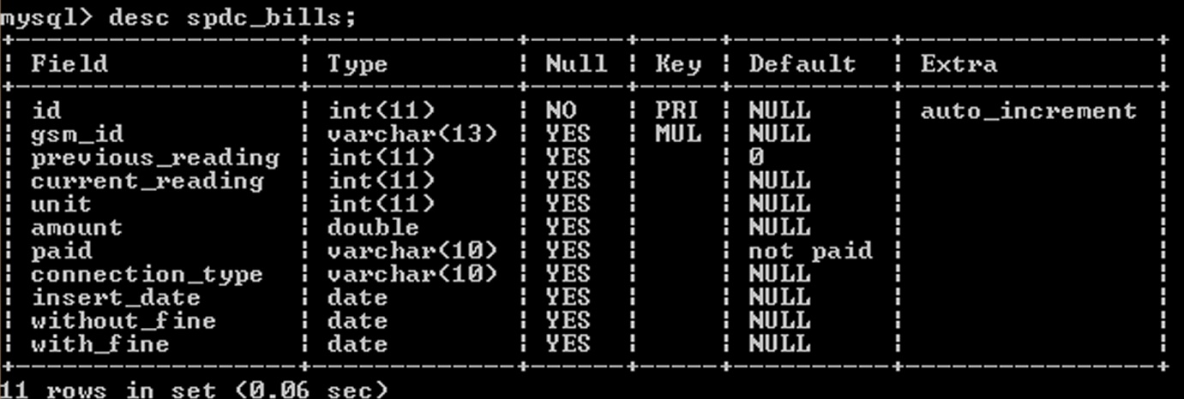

SPDC_ QUERY TABLE

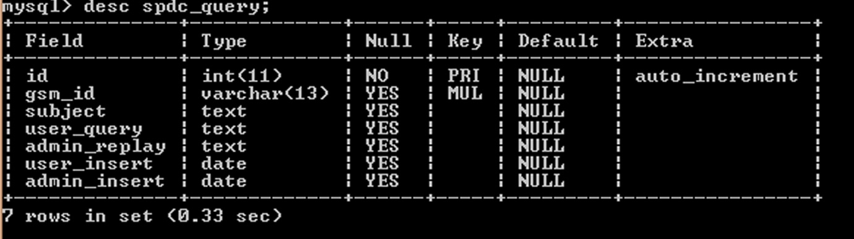

SPDC_ ADMIN TABLE

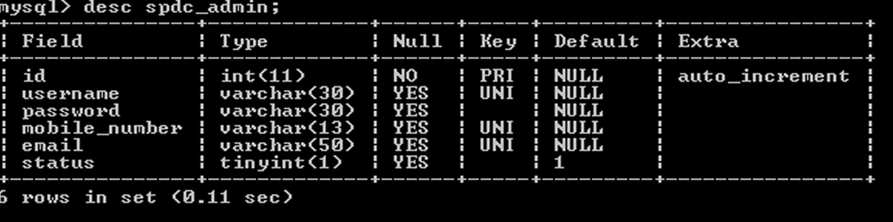

3.7 GANTT CHART

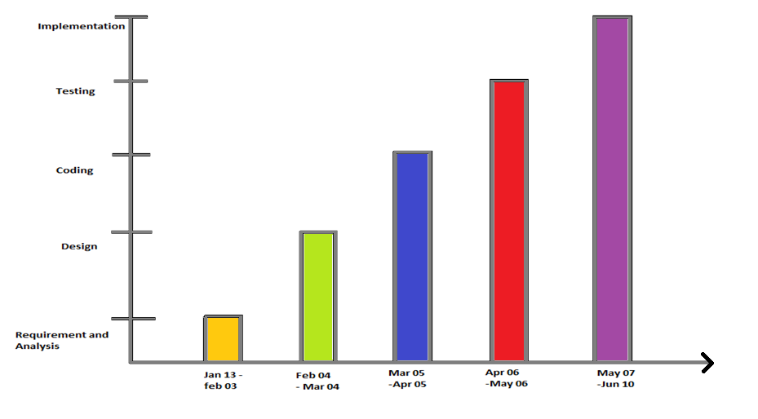

Jan 18-Mar 13

Mar 13-25

Mar 27-May 25

May 25-30

June 2-14

Req.anly

Planning

Design

Coding

Testing

Implementation

PROCESS

DATE

**4. SNAPSHOTS**

**SOURCE CODE**

1. Main Web Pages
2. Admin Web Pages
3. User Web Pages
4. Super Admin Web Pages
5. **Main Page**
   1. **Index.html**

<!DOCTYPE HTML>

<html>

<head>

<title>SOUTHERN POWER DISTRIBUTION COMPANY</title>

<meta name="viewport" content="width=device-width, initial-scale=1">

<meta http-equiv="Content-Type" content="text/html; charset=utf-8" />

<meta name="keywords" content="Skate Responsive web template, Bootstrap Web Templates, Flat Web Templates, Andriod Compatible web template,

Smartphone Compatible web template, free webdesigns for Nokia, Samsung, LG, SonyErricsson, Motorola web design" />

<script type="application/x-javascript"> addEventListener("load", function() { setTimeout(hideURLbar, 0); }, false); function hideURLbar(){ window.scrollTo(0,1); } </script>

<link href="css/bootstrap.css" rel='stylesheet' type='text/css' />

<link href="css/style.css" rel="stylesheet" type="text/css" media="all" />

<!-- start plugins -->

<script type="text/javascript" src="js/jquery-1.10.2.js"></script>

<script type="text/javascript" src="js/sampl.js"></script>

<script type="text/javascript" src="js/jquery.min.js"></script>

<!--start slider -->

<link rel="stylesheet" href="css/fwslider.css" media="all">

<script src="js/fwslider.js"></script>

<!--end slider -->

<!-- must have -->

<link href="css/allinone_carousel.css" rel="stylesheet" type="text/css">

<script src="js/jquery-ui-1.8.16.custom.min.js" type="text/javascript"></script>

<script src="js/allinone_carousel.js" type="text/javascript"></script>

<!--[if IE]><script src="js/excanvas.compiled.js" type="text/javascript"></script><![endif]-->

<!-- must have -->

<script>

jQuery(function() {

jQuery('#allinone_carousel_charming').allinone_carousel({

skin: 'charming',

width: 990,

height: 454,

responsive:true,

autoPlay: 3,

resizeImages:true,

autoHideBottomNav:false,

showElementTitle:false,

verticalAdjustment:50,

showPreviewThumbs:false,

//easing:'easeOutBounce',

numberOfVisibleItems:5,

nextPrevMarginTop:23,

playMovieMarginTop:0,

bottomNavMarginBottom:-10

});

});

function fo(){

window.history.forward();

}

</script>

<!-- Owl Carousel Assets -->

<link href="css/owl.carousel.css" rel="stylesheet">

<script src="js/owl.carousel.js"></script>

<script>

$(document).ready(function() {

$("#owl-demo").owlCarousel({

items : 4,

lazyLoad : true,

autoPlay : true,

navigation : true,

navigationText : ["", ""],

rewindNav : false,

scrollPerPage : false,

pagination : false,

paginationNumbers : false,

});

});

</script>

</head>

<body onload="fo()">

<div class="header_bg">

<div class="container">

<div class="header">

<div class="logo">

<h1><a>southern power distribution company</a></h1>

</div>

<div class="h_menu">

<a id="touch-menu" class="mobile-menu" href="#">Menu</a>

<nav>

<ul class="menu list-unstyled">

<li class="activate"><a href="index1.html">Home</a></li>

<li><a href="about.html">About</a></li>

<li><a href="indexlog.html">sign in</a>

<ul>

.

<li><a href="admin.html">Administration</a></li>

<li><a href="indexlog.html">USER</a></li>

</ul>

<li><a href="contact.html">Contact</a></li>

</ul>

</nav>

<script src="js/menu.js" type="text/javascript"></script>

</div>

<div class="clearfix"></div>

</div>

<div class="grid_12">

<img src="images/color_stripe.jpg" class="img-responsive" class="c_stripe">

</div>

</div>

</div>

<div id="fwslider"><!-- start slider -->

<div class="slider_container">

<div class="slide">

<!-- Slide image -->

<img src="images/slider1.jpg">

<!-- /Slide image -->

<!-- Texts container -->

<div class="slide_content">

<div class="slide_content_wrap">

<!-- Text title -->

<h2 class="title">ENERGY NEITHER BE CREATED, NOR BE DESTROYED</h2>

<!-- /Text title -->

<!-- Text description -->

<p class="description">BUT IT CAN TRANSFER FROM ONE TO ANOTHER</p>

<!-- /Text description -->

</div>

</div>

<!-- /Texts container -->

</div>

<!-- /Duplicate to create more slides -->

<div class="slide">

<img src="images/slider2.jpg">

<div class="slide_content">

<div class="slide_content_wrap">

</div>

</div>

</div>

<div class="slide">

<img src="images/slider3.jpg">

<div class="slide_content">

<div class="slide_content_wrap">

</div>

</div>

</div>

<!--/slide -->

</div>

<div class="timers"></div>

<div class="slidePrev"><span></span></div>

<div class="slideNext"><span></span></div>

</div><!--/slider -->

<div class="main_bg"><!-- start main -->

<div class="container">

<div class="main_grid">

<div class="top_grid"><!-- start top_grid -->

<div class="col-md-9 span1_of_1">

<h2>Importence of Electricity and energy concervation</h2>

<p>Energy conservation refers to reducing energy consumption through using less of an energy service. Energy conservation differs from efficient energy use, which refers to using less energy for a constant service.[1] For example, driving less is an example of energy conservation. Driving the same amount with a higher mileage vehicle is an example of energy efficiency. Energy conservation and efficiency are both energy reduction techniques.Even though energy conservation reduces energy services, it can result in increased environmental quality, national security, personal financial security and higher savings.[2] It is at the top of the sustainable energy hierarchy.[citation needed] It also lowers energy costs by preventing future resource depletion.Very small currents can be imperceptible. Larger current passing through the body may make it impossible for a shock victim to let go of an energized object. [3] Still larger currents can cause fibrillation of the heart and damage to tissues. Death caused by an electric shock is called electrocution.</p>

</div>

<div class="col-md-3 span1_of_2">

<a class="btn btn1" href="single-page.html">Read more</a>

</div>

<div class="clearfix"></div>

</div>

<div class="span_of_4"><!-- start span_of_4 -->

<div class="col-md-3 span1_of_4">

<div class="span4_of_list">

<div class="num">01</div>

<h3>ENERGY</h3>

<p>Electrical energy is energy newly derived from electrical potential energy. When loosely used to describe energy absorbed or delivered by an electrical circuit (for example, one provided by an electric power utility) "electrical energy" refers to energy which has been converted from electrical potential energy.conserve energy.</p>

<div class="read_more">

<a class="btn btn-2 active" href="single-page.html">Read more</a>

</div>

</div>

</div>

<div class="col-md-3 span1_of_4">

<div class="span4_of_list">

<div class="num">02</div>

<h3>MONEY</h3>

<p>For most people, the monthly electric bill accounts for a significant part of the monthly budget. In fact, the energy bill is often only surpassed by the mortgage or rent payment. It's usually in your best interest to keep it as low as possible, conserving energy and money. Scroll past the jump to learn how to start saving.</p>

<div class="read_more">

<a class="btn btn-2b" href="single-page.html">read more</a>

</div>

</div>

</div>

<div class="col-md-3 span1_of_4">

<div class="span4_of_list">

<div class="num">03</div>

<h3>SAFETY</h3>

<p>Electric shock is the physiological reaction or injury caused by electric current passing through the (human) body.[1] Typically, the expression is used to describe an injurious exposure to electricity.[2] It occurs upon contact of a (human) body part with any source of electricity that causes a sufficient current through the skin, muscles, or hair.

</p>

<div class="read_more">

<a class="btn btn-2b" href="single-page.html">read more</a>

</div>

</div>

</div>

<div class="col-md-3 span1_of_4">

<div class="span4_of_list">

<div class="num">04</div>

<h3>FUTURE</h3>

<p>The energy consumption in India is the fourth biggest after China, USA and Russia.[3] The total primary energy consumption from crude oil (29.45%), natural gas (7.7%), coal (54.5%), nuclear energy (1.26%), hydro electricity (5.0%), wind power, biomass electricity and solar power is 595 Mtoe in the year 2013.as considering the ennergy</p>

<div class="read_more">

<a class="btn btn-2b" href="single-page.html">read more</a>

</div>

</div>

</div>

<div class="clearfix"></div>

</div><!-- end span_of_4 -->

</div>

</div>

</div>

<div class="main1_bg"><!-- start main1 -->

<div class="container">

<div class="main slider_text texxt-center">

<h4>Our Motive</h4>

<p></p>

</div>

</div>

<!-- start banner -->

<div id="bannerBg">

<div id="containingDiv">

<div id="allinone_carousel_charming">

<div class="myloader"></div>

<!-- CONTENT -->

<ul class="allinone_carousel_list">

<li><img src="images/slider_pic1.jpg" alt="" class="img-responsive"/></li>

<li><img src="images/slider_pic2.jpg" alt="" class="img-responsive"/></li>

<li><img src="images/slider_pic3.jpg" alt="" class="img-responsive"/></li>

<li><img src="images/slider_pic4.jpg" alt="" class="img-responsive"/></li>

<li><img src="images/slider_pic5.jpg" alt="" class="img-responsive"/></li>

<li><img src="images/slider_pic3.jpg" alt="" class="img-responsive"/></li>

<li><img src="images/slider_pic4.jpg" alt="" class="img-responsive"/></li>

<li><img src="images/slider_pic5.jpg" alt="" class="img-responsive"/></li>

</ul>

</div>

</div>

</div>

<!-- end banner -->

</div>

<div class="main_btm"><!-- start main_btm -->

<div class="container">

<div class="cau_hide">

</div>

</div>

</div>

<div class="footer_bg"><!-- start footer -->

<div class="container">

<div class="footer">

<div class="clearfix"></div>

</div>

</div>

</div>

<div class="footer1_bg"><!-- start footer1 -->

<div class="container">

<div class="footer1">

<div class="copy pull-left">

<p class="link"><span>&#169; All rights reserved | Design by<a href="http://google.com/">Team Awsome</a></span></p>

</div>

<div class="soc_icons pull-right">

<ul class="list-unstyled text-center">

<li><a href="https://twitter.com/"><i class="fa fa-twitter"></i></a></li>

<li><a href="https://www.facebook.com/"><i class="fa fa-facebook"></i></a></li>

<li><a href="https://accounts.google.com/"><i class="fa fa-google-plus"></i></a></li>

<li><a href="#"><i class="fa fa-rss"></i></a></li>

</ul>

</div>

<div class="clearfix"></div>

</div>

</div>

</div>

</body>

</html>

* 1. **Admin Login Page**

<!--

Author: W3layouts

Author URL: http://w3layouts.com

License: Creative Commons Attribution 3.0 Unported

License URL: http://creativecommons.org/licenses/by/3.0/

-->

<!DOCTYPE html>

<html>

<head>

<title>The Login-Animated Website Template | Home :: w3layouts</title>

<meta charset="utf-8">

<link href="css1/style.css" rel='stylesheet' type='text/css' />

<meta name="viewport" content="width=device-width, initial-scale=1">

<script type="application/x-javascript"> addEventListener("load", function() { setTimeout(hideURLbar, 0); }, false); function hideURLbar(){ window.scrollTo(0,1); } </script>

<!--webfonts-->

<link href='http://fonts.googleapis.com/css?family=Open+Sans:600italic,400,300,600,700' rel='stylesheet' type='text/css'>

<!--//webfonts-->

<script type="text/javascript" src="js/jquery-1.10.2.js"></script>

<script type="text/javascript" src="js/sample.js"></script>

</head>

<body>

<div class="login-form">

<div class="head">

<img src="images/mem2.jpg" alt=""/>

</div>

<form action="admin.jsp" method="post">

<li>

<input type="text" class="text" name="adminid" value="Adminid" onfocus="this.value = '';" onblur="if (this.value == '') {this.value = 'USERNAME';}" ><a href="#" class=" icon user"></a>

</li>

<li>

<input type="password" name="adminpass" value="Password" onfocus="this.value = '';" onblur="if (this.value == '') {this.value = 'Password';}"><a href="#" class=" icon lock"></a>

</li>

<div class="p-container">

<label class="checkbox"><input type="checkbox" name="checkbox" checked><i></i>Remember Me</label><br><br><br>

<br><input type="submit" onclick="myFunction()" value="SIGN IN" ><a href="forgot_password.html">Forgot Password?</a>

<div class="clear"> </div>

</div>

</form>

</div>

</body>

</html>

* 1. **Admin.jsp**

<%@page import="java.sql.*"%>

<%@ page language="java" contentType="text/html; charset=ISO-8859-1"

pageEncoding="ISO-8859-1"%>

<!DOCTYPE html PUBLIC "-//W3C//DTD HTML 4.01 Transitional//EN" "http://www.w3.org/TR/html4/loose.dtd">

<html>

<head>

<meta http-equiv="Content-Type" content="text/html; charset=ISO-8859-1">

<title>Insert title here</title>

</head>

<body>

<%

try

{

String usn=request.getParameter("adminid");

String pass=request.getParameter("adminpass");

//String ad_name,ad_pass;

Class.forName("com.mysql.jdbc.Driver");

Connection connection=DriverManager.getConnection("jdbc:mysql://localhost/SPDC?"

+"user=root&password=jishnu");

PreparedStatement ps = null;

ResultSet rs = null;

ps = connection.prepareStatement("select * from SPDC_ADMIN where username='"+usn+"' and password='"+pass+"'");

rs = ps.executeQuery();

/* String s=null;

String g=null;

*/

if(rs.next())

{

session.setAttribute("spdc",usn);

response.sendRedirect("http://localhost:9895/SPDC/main-admin_pages/index.jsp");

}

else

{

out.write("<script type='text/javascript'>\n");

out.write("alert('Wrong Username or Password !!!!!');\n");

out.write("window.location.href='http://localhost:9895/SPDC/main_web_pages/admin.html';");

out.write("</script>\n");

}

}

catch(Exception e)

{

e.printStackTrace();

}

%>

</body>

</html>

* 1. Indexlog.html

<!--

Author: W3layouts

Author URL: http://w3layouts.com

License: Creative Commons Attribution 3.0 Unported

License URL: http://creativecommons.org/licenses/by/3.0/

-->

<!DOCTYPE html>

<html>

<head>

<title></title>

<meta charset="utf-8">

<link href="css1/style.css" rel='stylesheet' type='text/css' />

<meta name="viewport" content="width=device-width, initial-scale=1">

<script type="application/x-javascript"> addEventListener("load", function() { setTimeout(hideURLbar, 0); }, false); function hideURLbar(){ window.scrollTo(0,1); } </script>

<!--webfonts-->

<link href='http://fonts.googleapis.com/css?family=Open+Sans:600italic,400,300,600,700' rel='stylesheet' type='text/css'>

<!--//webfonts-->

<script type="text/javascript" src="js/jquery-1.10.2.js"></script>

<script type="text/javascript" src="js/sample.js"></script>

</head>

<body>

<div class="login-form">

<div class="head">

<img src="images/mem2.jpg" alt=""/>

</div>

<form action="user.jsp" method="post">

<li>

<input type="text" class="text" name="gsm_id" value="USERNAME" onfocus="this.value = '';" onblur="if (this.value == '') {this.value = 'USERNAME';}" ><a href="#" class=" icon user"></a>

</li>

<li>

<input type="password" name="password" value="Password" onfocus="this.value = '';" onblur="if (this.value == '') {this.value = 'Password';}"><a href="#" class=" icon lock"></a>

</li>

<div class="p-container">

<label class="checkbox"><input type="checkbox" name="checkbox" checked><i></i>Remember Me</label><br><br><br>

<br><input type="submit" onclick="myFunction()" value="SIGN IN" ><a href="forgot_password.html">Forgot Password?</a>

<div class="clear"> </div>

</div>

</form>

</div>

</body>

</html>

* 1. **User.jsp**

<%@page import="java.sql.*"%>

<%@ page language="java" contentType="text/html; charset=ISO-8859-1"

pageEncoding="ISO-8859-1"%>

<!DOCTYPE html PUBLIC "-//W3C//DTD HTML 4.01 Transitional//EN" "http://www.w3.org/TR/html4/loose.dtd">

<html>

<head>

<meta http-equiv="Content-Type" content="text/html; charset=ISO-8859-1">

<title>Insert title here</title>

</head>

<body>

<%

try

{

String usn=request.getParameter("gsm_id");

String pass=request.getParameter("password");

Class.forName("com.mysql.jdbc.Driver");

Connection connection=DriverManager.getConnection("jdbc:mysql://localhost/SPDC?"

+"user=root&password=jishnu");

Statement st=connection.createStatement();

ResultSet rs=st.executeQuery("select * from SPDC_USER_PROFILE where gsm_id='"+usn+"' and password='"+pass+"'");

if(rs.next())

{

session.setAttribute("spdc",usn);

response.sendRedirect("http://localhost:9895/SPDC/main-user_pages/index.jsp");

}

else

{

out.write("<script type='text/javascript'>\n");

out.write("alert('Wrong Username or Password !!!!!');\n");

out.write("window.location.href='http://localhost:9895/SPDC/main_web_pages/indexlog.html';");

out.write("</script>\n");

}

}

catch(Exception e)

{

e.printStackTrace();

}

%>

</body>

</html>

* 1. CheckTable.jsp

<%@page import="java.sql.*"%>

<%@ page language="java" contentType="text/html; charset=ISO-8859-1"

pageEncoding="ISO-8859-1"%>

<!DOCTYPE html PUBLIC "-//W3C//DTD HTML 4.01 Transitional//EN" "http://www.w3.org/TR/html4/loose.dtd">

<html>

<head>

<meta http-equiv="Content-Type" content="text/html; charset=ISO-8859-1">

<title>Insert title here</title>

</head>

<body>

<%

Class.forName("com.mysql.jdbc.Driver");

Connection connection=DriverManager.getConnection("jdbc:mysql://localhost/SPDC?"

+"user=root&password=jishnu");

PreparedStatement ps = null;

ResultSet rs = null;

ps = connection.prepareStatement("select * from information_schema.tables where table_schema='SPDC' and table_name='SPDC_ADMIN'");

rs = ps.executeQuery();

if (rs.next())

{

System.out.println("SPDC_ADMIN Table Exists");

}

else

{

System.out.println("SPDC_ADMIN Table not Exists");

ps = connection.prepareStatement("create table SPDC_ADMIN(id int primary key AUTO_INCREMENT, username varchar(30) unique, password varchar(30), mobile_number varchar(13) unique, email varchar(50) unique, status Boolean default true)");

ps.execute();

}

ps = connection.prepareStatement("select * from information_schema.tables where table_schema='SPDC' and table_name='SPDC_USER_PROFILE'");

rs = ps.executeQuery();

if (rs.next())

{

System.out.println("SPDC_USER_PROFILE Table Exists");

}

else

{

System.out.println("SPDC_USER_PROFILE Table not Exists");

ps = connection.prepareStatement("create table SPDC_USER_PROFILE(id int primary key auto_increment,gsm_id varchar(13) unique ,password varchar(50) ,email varchar(50) unique,mobile_number varchar(13) unique,customer_name varchar(50),date_of_birth date,house_no varchar(20),post varchar(20),city varchar(20),districts varchar(20),state varchar(20),country varchar(20),is_active boolean default true ,connection_type varchar(10),status boolean default True) ENGINE=INNODB");

ps.execute();

}

ps = connection.prepareStatement("select * from information_schema.tables where table_schema='SPDC' and table_name='SPDC_BILLS'");

rs = ps.executeQuery();

if (rs.next())

{

System.out.println("SPDC_BILLS Table Exists");

}

else

{

System.out.println("SPDC_BILLS Table not Exists");

ps = connection.prepareStatement("create table SPDC_BILLS(id int primary key auto_increment, gsm_id varchar(13), previous_reading int default 0, current_reading int, unit int,amount double, paid varchar(10) default 'not paid' ,connection_type varchar(10),insert_date date,without_fine date,with_fine date, FOREIGN KEY (gsm_id) references SPDC_USER_PROFILE(gsm_id) ON DELETE CASCADE)ENGINE=INNODB");

ps.execute();

}

ps = connection.prepareStatement("select * from information_schema.tables where table_schema='SPDC' and table_name='SPDC_QUERY'");

rs = ps.executeQuery();

if (rs.next())

{

System.out.println("SPDC_QUERY Table Exists");

}

else

{

System.out.println("SPDC_QUERY Table not Exists");

ps = connection.prepareStatement("create table SPDC_QUERY (id int primary key auto_increment,gsm_id varchar(13), subject text, user_query text, admin_replay text,user_insert date,admin_insert date,FOREIGN KEY (gsm_id) references SPDC_USER_PROFILE(gsm_id) ON DELETE CASCADE) ENGINE=INNODB");

ps.execute();

}

ps = connection.prepareStatement("select * from information_schema.tables where table_schema='SPDC' and table_name='SPDC_LT'");

rs = ps.executeQuery();

if (rs.next())

{

System.out.println("SPDC_QUERY Table Exists");

}

else

{

System.out.println("SPDC_LT Table not Exists");

ps = connection.prepareStatement("create table SPDC_LT (id int primary key auto_increment,connection_type varchar(13), first double, second double, third double, fourth double, meter int,sms int) ENGINE=INNODB");

ps.execute();

ps = connection.prepareStatement("insert into spdc_lt(connection_type,first,second,third,fourth,meter,sms) values ('LT1A',1.8,1.5,1.3,1.4,40,20)");

ps.execute();

}

%>

</body>

</html>

1. **Admin Pages**
   1. **Customers.jsp**

<%@page import="java.sql.*"%>

<%@page import="java.util.*"%>

<%@page import="java.util.Properties"%>

<%@page import="java.net.*"%>

<%@ page language="java" contentType="text/html; charset=ISO-8859-1"

pageEncoding="ISO-8859-1"%>

<!DOCTYPE html PUBLIC "-//W3C//DTD HTML 4.01 Transitional//EN" "http://www.w3.org/TR/html4/loose.dtd">

<html>

<head>

<meta http-equiv="Content-Type" content="text/html; charset=ISO-8859-1">

<meta name="viewport" content="width=device-width, initial-scale=1.0" />

<title>UserPage</title>

<!-- BOOTSTRAP STYLES-->

<link href="assets/css/bootstrap.css" rel="stylesheet" />

<!-- FONTAWESOME ICONS STYLES-->

<link href="assets/css/font-awesome.css" rel="stylesheet" />

<!--CUSTOM STYLES-->

<link href="assets/css/style.css" rel="stylesheet" />

</head>

<body>

<div id="wrapper">

<nav class="navbar navbar-default navbar-cls-top " role="navigation"

style="margin-bottom: 0">

<div class="navbar-header">

<button type="button" class="navbar-toggle" data-toggle="collapse"

data-target=".sidebar-collapse">

<span class="sr-only">Toggle navigation</span> <span

class="icon-bar"></span> <span class="icon-bar"></span> <span

class="icon-bar"></span>

</button>

<a class="navbar-brand" href="index.jsp">SPDC </a>

</div>

<div class="notifications-wrapper">

<ul class="nav">

<li class="dropdown"><a class="dropdown-toggle"

data-toggle="dropdown" href="#"> <B>SETTINGS </B> <i

class="fa fa-user-plus"></i> <i class="fa fa-caret-down"></i>

</a>

<ul class="dropdown-menu dropdown-user">

<li><a href="update.html"><i class="fa fa-user-plus"></i>

My Profile</a></li>

<li class="divider"></li>

<li><a href="change_password.jsp"><i class="fa fa-user-plus"></i>

Change Password</a></li>

<li class="divider"></li>

<li><a href="logout.jsp"><i class="fa fa-sign-out"></i> Logout</a></li>

</ul></li>

</ul>

</div>

</nav>

<!-- /. NAV TOP -->

<nav class="navbar-default navbar-side" role="navigation">

<div class="sidebar-collapse">

<ul class="nav" id="main-menu">

<li>

<div class="user-img-div">

<img src="assets/img/user.jpg" class="img-circle" />

</div>

<%

String username=(String)session.getAttribute("spdc");

%>

</li>

<li><a> <strong> Welcome <%=username %> </strong></a></li>

<li><a href="index.jsp"><%=username %> Home</a></li>

<li><a href="customers.jsp">Customers</a></li>

<li><a href="Registration_form.jsp">Registration</a></li>

<!-- <li><a href="Payment.html">Payments</a></li> -->

<li><a>Bill Details <span><i

class="fa fa-caret-down"></i></span></a>

<ul class="nav nav-second-level">

<li><a href="view_bills.jsp">View Bill</a></li>

<li><a href="generate_bill_main.html">Generate Bill</a></li>

</ul></li>

<li><a class="active-menu" href="queries_main.jsp">Read Queries</a>

</li>

</ul>

</div>

</nav>

<!-- /. SIDEBAR MENU (navbar-side) -->

<%

PreparedStatement ps = null;

ResultSet rs = null;

Class.forName("com.mysql.jdbc.Driver");

Connection connection=DriverManager.getConnection("jdbc:mysql://localhost/SPDC?"

+"user=root&password=jishnu");

ps = connection.prepareStatement("select * from SPDC_USER_PROFILE");

rs = ps.executeQuery();

%>

<div id="page-wrapper" class="page-wrapper-cls">

<div id="page-inner">

<div class="row">

<div class="panel panel-default">

<div class="panel-heading">CUSTOMER DETAILS</div>

<div class="panel-body">

<div class="table-responsive">

<table class="table table-striped table-bordered table-hover">

<thead>

<tr>

<th></th>

<th>GSM ID</th>

<th>MOBILE NUMBER</th>

<th>NAME</th>

<th>HOUSE NUMBER</th>

<th>POST</th>

<th>TOWN</th>

<th></th>

</tr>

</thead>

<tbody>

<%while(rs.next())

{%>

<tr>

<td><input type="checkbox" name="checkbox"

id=<%=rs.getInt(1) %> value="value"></td>

<td><%=rs.getString(2) %></td>

<td><%=rs.getString(5) %></td>

<td><%=rs.getString(6) %></td>

<td><%=rs.getString(8) %></td>

<td><%=rs.getString(9) %></td>

<td><%=rs.getString(10) %></td>

<td><a href='edit_customers_form.jsp?id=<%=rs.getInt(1) %>'><button type="button">View</a></td>

</tr>

<%

}

%>

</tbody>

</table>

</div>

</div>

</div>

</div>

</div>

</div>

<footer> &copy; 2015 YourCompany | By : <a

href="http://www.designbootstrap.com/" target="_blank"></a> </footer>

<!-- /. FOOTER -->

<!-- SCRIPTS -AT THE BOTOM TO REDUCE THE LOAD TIME-->

<!-- JQUERY SCRIPTS -->

<script src="assets/js/jquery-1.11.1.js"></script>

<!-- BOOTSTRAP SCRIPTS -->

<script src="assets/js/bootstrap.js"></script>

<!-- METISMENU SCRIPTS -->

<script src="assets/js/jquery.metisMenu.js"></script>

<!-- CUSTOM SCRIPTS -->

<script src="assets/js/custom.js"></script>

</body>

</html>

* 1. Registration_form.jsp

<%@ page language="java" contentType="text/html; charset=ISO-8859-1"

pageEncoding="ISO-8859-1"%>

<!DOCTYPE html PUBLIC "-//W3C//DTD HTML 4.01 Transitional//EN" "http://www.w3.org/TR/html4/loose.dtd">

<html>

<head>

<meta http-equiv="Content-Type" content="text/html; charset=ISO-8859-1">

<meta name="viewport" content="width=device-width, initial-scale=1.0" />

<title>UserPage</title>

<!-- BOOTSTRAP STYLES-->

<link href="assets/css/bootstrap.css" rel="stylesheet" />

<!-- FONTAWESOME ICONS STYLES-->

<link href="assets/css/font-awesome.css" rel="stylesheet" />

<!--CUSTOM STYLES-->

<link href="assets/css/style.css" rel="stylesheet" />

</head>

<body>

<div id="wrapper">

<nav class="navbar navbar-default navbar-cls-top " role="navigation" style="margin-bottom: 0">

<div class="navbar-header">

<button type="button" class="navbar-toggle" data-toggle="collapse" data-target=".sidebar-collapse">

<span class="sr-only">Toggle navigation</span>

<span class="icon-bar"></span>

<span class="icon-bar"></span>

<span class="icon-bar"></span>

</button>

<a class="navbar-brand" href="index.jsp">SPDC

</a>

</div>

<div class="notifications-wrapper">

<ul class="nav">

<li class="dropdown">

<a class="dropdown-toggle" data-toggle="dropdown" href="#">

<B>SETTINGS </B>

<i class="fa fa-user-plus"></i> <i class="fa fa-caret-down"></i>

</a>

<ul class="dropdown-menu dropdown-user">

<li><a href="update.html"><i class="fa fa-user-plus"></i> My Profile</a>

</li>

<li class="divider"></li>

<li><a href="change_password.jsp"><i class="fa fa-user-plus"></i> Change Password</a>

</li>

<li class="divider"></li>

<li><a href="logout.jsp"><i class="fa fa-sign-out"></i> Logout</a>

</li>

</ul>

</li>

</ul>

</div>

</nav>

<!-- /. NAV TOP -->

<nav class="navbar-default navbar-side" role="navigation">

<div class="sidebar-collapse">

<ul class="nav" id="main-menu">

<li>

<div class="user-img-div">

<img src="assets/img/user.jpg" class="img-circle" />

</div>

<%

String username=(String)session.getAttribute("spdc");

%>

</li>

<li>

<a> <strong> Welcome <%=username %> </strong></a>

</li>

<li>

<a href="index.jsp"><%=username %>Home</a>

</li>

<li><a href="customers.jsp">Customers</a></li>

<li>

<a class="active-menu" href="Registration.html">Registration</a>

</li>

<!-- <li>

<a href="Payment.html">Payments</a>

</li> -->

<li>

<a>Bill Details <span ><i class="fa fa-caret-down"></i></span></a>

<ul class="nav nav-second-level">

<li>

<a href="view_bills.jsp">View Bill</a>

</li>

<li>

<a href="generate_bill_main.html">Generate Bill</a>

</li>

</ul>

</li>

<li>

<a href="queries_main.jsp">Read Queries</a>

</li>

</ul>

</div>

</nav>

<!-- /. SIDEBAR MENU (navbar-side) -->

<div id="page-wrapper" class="page-wrapper-cls">

<div id="page-inner">

<div class="row">

<div id="page-wrapper" class="page-wrapper-cls">

<div id="page-inner">

<div class="row">

<div class="col-md-12">

<h1 class="page-head-line">Registration </h1>

</div>

</div>

<div class="row">

<div class="col-md-6">

<div class="panel panel-default">

<div class="panel-body">

<form action="Registration.jsp" method="post">

<div class="form-group">

<label for="exampleInputgsmid">GSM-ID</label>

<input type="text" class="form-control" id="exampleInputEmail1" placeholder="Enter GSM-ID" value="+91" name="gsm_id" />

</div>

<hr />

<label for="exampleInputmobileno">MOBILE-NO</label>

<input type="text" class="form-control" id="exampleInputmobileno" placeholder="Enter MOBILE-NO" value="+91" name="mob" />

<hr/>

<label for="exampleInputmobileno">Connection Type</label>

<select name="type_connection">

<option>LT1A</option>

<option>LT5</option>

<option>LT7</option>

</select>

<hr/>

<button type="submit" class="btn btn-default">Submit</button>

</form>

</div>

</div>

</div>

</div>

</div>

</div>

</div>

</div>

</div>

<footer >

&copy; 2015 YourCompany | By : <a href="http://www.designbootstrap.com/" target="_blank"></a>

</footer>

<!-- /. FOOTER -->

<!-- SCRIPTS -AT THE BOTOM TO REDUCE THE LOAD TIME-->

<!-- JQUERY SCRIPTS -->

<script src="assets/js/jquery-1.11.1.js"></script>

<!-- BOOTSTRAP SCRIPTS -->

<script src="assets/js/bootstrap.js"></script>

<!-- METISMENU SCRIPTS -->

<script src="assets/js/jquery.metisMenu.js"></script>

<!-- CUSTOM SCRIPTS -->

<script src="assets/js/custom.js"></script>

</body>

</html>

* 1. Registation.jsp

<%@page import="java.sql.*"%>

<%@page import="java.util.*"%>

<%@page import="java.util.Properties"%>

<%@page import="java.net.*"%>

<%@ page language="java" contentType="text/html; charset=ISO-8859-1"

pageEncoding="ISO-8859-1"%>

<!DOCTYPE html PUBLIC "-//W3C//DTD HTML 4.01 Transitional//EN" "http://www.w3.org/TR/html4/loose.dtd">

<html>

<head>

<meta http-equiv="Content-Type" content="text/html; charset=ISO-8859-1">

<title>Insert title here</title>

</head>

<body>

<%!

int gsm_flag=0;

int mob_flag=0;

//Statement stmt = null;

PreparedStatement ps =null;

ResultSet rs = null;

public String re;

//FUNCTION TO CREATE RANDOM PASSWORD

public int password_gen()

{

Random t=new Random();

return(t.nextInt(100000));

}

// FUNCTION USED FOR SENDING SMS TO CLIENT MONILE NUMBER

public void send_sms(String gsm,String pass,String mob)

{

String requestUrl ;

String recipient =mob;

String message = "Login ID:" +gsm+"\n Password:"+pass;

String username = "admin";

String password = "admin";

String originator = "+918281424452";

try

{

requestUrl = "http://127.0.0.1:9501/api?action=sendmessage&" +

"username=" + URLEncoder.encode(username, "UTF-8") +

"&password=" + URLEncoder.encode(password, "UTF-8") +

"&recipient=" + URLEncoder.encode(recipient, "UTF-8") +

"&messagetype=SMS:TEXT" +

"&messagedata=" + URLEncoder.encode(message, "UTF-8") +

"&originator=" + URLEncoder.encode(originator, "UTF-8") +

"&serviceprovider=GSMModem4" +

"&responseformat=html";

URL url = new URL(requestUrl);

HttpURLConnection uc = (HttpURLConnection)url.openConnection();

uc.getResponseMessage();

uc.disconnect();

}

catch(Exception ex)

{

System.out.println(ex.getMessage());

}

}

%>

<%

gsm_flag=0;

mob_flag=0;

//DB CONNECTION

Class.forName("com.mysql.jdbc.Driver");

Connection connection=DriverManager.getConnection("jdbc:mysql://localhost/SPDC?"

+"user=root&password=jishnu");

String gsm=request.getParameter("gsm_id");

String mob=request.getParameter("mob");

String type=request.getParameter("type_connection");

String pass=String.valueOf(password_gen());

System.out.println(gsm);

System.out.println(mob);

System.out.println(pass);

//CHECKING GSM-ID WHETHER ITS ALREADY REGISTERED WITH US

ps=connection.prepareStatement("select * from SPDC_USER_PROFILE where gsm_id=?");

ps.setString(1, gsm);

ResultSet rs = ps.executeQuery();

if (rs.next())

{

System.out.println("gsm id exists");

gsm_flag = 1;

out.write("<script type='text/javascript'>\n");

out.write("alert(' Entered GSM ID is already exists ');\n");

out.write("window.location.href='http://localhost:9895/SPDC/main-admin_pages/Registration_form.jsp';");

out.write("</script>\n");

}

//CHECKING MOBILE NUMBER IS ALREADY REGISTERED WITH US

ps=connection.prepareStatement("select * from SPDC_USER_PROFILE where mobile_number=?");

ps.setString(1, mob);

rs = ps.executeQuery();

if (rs.next())

{

System.out.println("inside mobile number check");

mob_flag = 1;

out.write("<script type='text/javascript'>\n");

out.write("alert(' Entered Mobile Number is already exists ');\n");

out.write("window.location.href='http://localhost:9895/SPDC/main-admin_pages/Registration_form.jsp';");

out.write("</script>\n");

}

//SAVING CUSTOMER DETAILS TO DB

if (mob_flag==0 && gsm_flag==0)

{

System.out.println("inside ok");

try

{

/* String null_value = null; */

String insert_data="insert into SPDC_USER_PROFILE (GSM_ID,PASSWORD,MOBILE_NUMBER,CONNECTION_TYPE) values(?,?,?,?)";

ps=connection.prepareStatement(insert_data);

ps.setString(1, gsm);

ps.setString(2, pass);

ps.setString(3, mob);

ps.setString(4, type);

/* ps.setString(4, null_value );

ps.setString(5, null_value);

ps.setString(6, null_value);

ps.setString(7, null_value);

ps.setString(8, null_value);

ps.setString(9, null_value);

ps.setString(10, null_value);

ps.setString(11, null_value); */

//ps.setString(2, "123456");

ps.execute();

//SENDING SMS AFTER SAVING CUSTIOMER DETAILS

send_sms(gsm,pass,mob);

out.write("<script type='text/javascript'>\n");

out.write("alert('Registration Completed Successfully!!!!!');\n");

out.write("window.location.href='http://localhost:9895/SPDC/main-admin_pages/Registration_form.jsp';");

out.write("</script>\n");

}

catch(Exception e)

{

e.printStackTrace();

}

}

%>

</body>

</html>

* 1. Update_bills.jsp

<%@page import="java.text.SimpleDateFormat"%>

<%@ page import="java.io.*"%>

<%@ page import="java.util.*"%>

<%@page import="java.sql.*"%>

<%@page import="java.net.*"%>

<%@ page language="java" contentType="text/html; charset=ISO-8859-1"

pageEncoding="ISO-8859-1"%>

<!DOCTYPE html PUBLIC "-//W3C//DTD HTML 4.01 Transitional//EN" "http://www.w3.org/TR/html4/loose.dtd">

<html>

<head>

<meta http-equiv="Content-Type" content="text/html; charset=ISO-8859-1">

<title>Insert title here</title>

</head>

<body>

<%!

double lt_first,lt_second,lt_third,lt_fourth,lt_meter,lt_sms,fine_amount=0;

public void send_sms(int unit,double amount,int current_unit,int previous_unit,String mobile_number,String gsm,String pay_without_fail,String pay_with_fail,double fine_amount)

{

String requestUrl ;

String recipient =mobile_number;

String message = "Electricity Bill:\n GSM ID:" +gsm+"\n Previous Reading:"+previous_unit+"\n Current Reading:"+current_unit+"\n Consumed Unit:"+unit+"\n Amount to be paid:"+amount+"\n last date without due:"+pay_without_fail+"\n last date with fine:"+pay_with_fail+"\n Fine Amount:"+fine_amount;

String username = "admin";

String password = "admin";

String originator = "+918281424452";

try

{

requestUrl = "http://127.0.0.1:9501/api?action=sendmessage&" +

"username=" + URLEncoder.encode(username, "UTF-8") +

"&password=" + URLEncoder.encode(password, "UTF-8") +

"&recipient=" + URLEncoder.encode(recipient, "UTF-8") +

"&messagetype=SMS:TEXT" +

"&messagedata=" + URLEncoder.encode(message, "UTF-8") +

"&originator=" + URLEncoder.encode(originator, "UTF-8") +

"&serviceprovider=GSMModem4" +

"&responseformat=html";

URL url = new URL(requestUrl);

HttpURLConnection uc = (HttpURLConnection)url.openConnection();

uc.getResponseMessage();

uc.disconnect();

}

catch(Exception ex)

{

System.out.println(ex.getMessage());

}

}

%>

<%

/*-------------------------Variables------------------*/

int previous_unit = 0;

int current_unit = 0;

int unit = 0;

double amount = 0;

String type_connection,mobile_number = null;

PreparedStatement ps = null;

ResultSet rs = null;

/*---------------------------DB Connection -----------------------------*/

Class.forName("com.mysql.jdbc.Driver");

Connection connection=DriverManager.getConnection("jdbc:mysql://localhost/SPDC?"

+"user=root&password=jishnu");

Calendar c = Calendar.getInstance();

/*---------------------Current month and year------------------------*/

SimpleDateFormat sdf = new SimpleDateFormat("yy-MM");

String current_month = sdf.format(Calendar.getInstance().getTime());

System.out.println(current_month);

/*---------------------Previous month and year------------------------*/

Calendar cal = Calendar.getInstance();

cal.add(Calendar.MONTH, -1);

String previous_month = new SimpleDateFormat("yy-MM").format(cal.getTime());

System.out.println(previous_month);

/*---------------------pay_without_fail------------------------*/

Calendar cale = Calendar.getInstance();

cale.add(Calendar.DAY_OF_MONTH, +15);

java.util.Date ccc= cale.getTime();

java.sql.Date pay_without_fail = new java.sql.Date (ccc.getTime());

String pay_without_fail1 = new SimpleDateFormat("yyyy-MM-dd").format(cale.getTime());

System.out.println(pay_without_fail);

/*---------------------pay_with_fail------------------------*/

Calendar calen = Calendar.getInstance();

calen.add(Calendar.DAY_OF_MONTH, +25);

java.util.Date cc= calen.getTime();

java.sql.Date pay_with_fail = new java.sql.Date (cc.getTime());

String pay_with_fail1 = new SimpleDateFormat("yyyy-MM-dd").format(calen.getTime());

System.out.println(pay_with_fail);

/*---------------------------DB Date format-------------------*/

java.util.Date date = Calendar.getInstance().getTime();

java.sql.Date sqlDate = new java.sql.Date(date.getTime());

/*---------------current date-------*/

SimpleDateFormat sdf_date = new SimpleDateFormat("dd");

String current_date = sdf_date.format(Calendar.getInstance().getTime());

File file = new File("E:\\inputsms.txt");

if(current_date.equals("27"))

{

/*------------------ rates----------------------*/

ps = connection.prepareStatement("select * from SPDC_LT");

rs = ps.executeQuery();

while(rs.next())

{

if(rs.getString(2).equals("LT1A"))

{

lt_first = rs.getDouble(3);

lt_second = rs.getDouble(4);

lt_third = rs.getDouble(5);

lt_fourth = rs.getDouble(6);

lt_meter = rs.getInt(7);

lt_sms = rs.getInt(8);

}

/* else

{

lt5_first = rs.getDouble(3);

lt5_meter = rs.getInt(7);

lt5_sms = rs.getInt(8);

} */

}

/*--------------------------------File Reading------------------------------------*/

if(file.exists())

{

FileReader fr = new FileReader("E:/inputsms.txt");

BufferedReader br = new BufferedReader(fr);

String line = br.readLine();

while (line != null) {

String[] parts = line.split(" ");

System.out.println(parts[0]);// mobile number

System.out.println(parts[1]);// reading

/*------------------------ Checks the gsm id is registered with us -----------------*/

ps = connection.prepareStatement("select * from spdc_user_profile where gsm_id = ?");

ps.setString(1, parts[0]);

rs = ps.executeQuery();

if (rs.next()) {

type_connection = rs.getString(15);

mobile_number = rs.getString(5);

/*------------------ rates----------------------*/

ps = connection.prepareStatement("select * from SPDC_LT where type_connection = ?");

ps.setString(1, type_connection);

rs = ps.executeQuery();

if(rs.next())

{

if(type_connection.equals("LT1A"))

{

lt_first = rs.getDouble(3);

lt_second = rs.getDouble(4);

lt_third = rs.getDouble(5);

lt_fourth = rs.getDouble(6);

lt_meter = rs.getInt(7);

lt_sms = rs.getInt(8);

}

else

{

lt_first = rs.getDouble(3);

lt_meter = rs.getInt(7);

lt_sms = rs.getInt(8);

}

}

/*------------------ checks whether the bill is genereted for the current month --------------------*/

ps = connection.prepareStatement("select * from spdc_bills where gsm_id = ? and insert_date like '%"+current_month+"%'");

ps.setString(1, parts[0]);

rs = ps.executeQuery();

if (!rs.next()) {

/*-----------------------------Collecting previous bill data-------------------------------*/

ps = connection.prepareStatement("select * from spdc_bills where gsm_id = ? and insert_date like '%"+previous_month+"%'");

ps.setString(1, parts[0]);

rs = ps.executeQuery();

if (rs.next()) {

previous_unit = rs.getInt(3);

current_unit = Integer.parseInt(parts[1]);

unit = current_unit - previous_unit;

}

else

{ previous_unit = 0;

current_unit = Integer.parseInt(parts[1]);

unit = current_unit - previous_unit;

}

if (type_connection.equals("LT1A"))

{

for (int i = 0; i < unit; i++)

{

if(i > 150)

amount = amount + lt_fourth;

else if(i > 120)

amount = amount + lt_third;

else if(i > 80)

amount = amount + lt_second;

else

amount = amount + lt_first;

}

amount = amount+lt_meter;

amount = amount+lt_sms;

amount = amount+(amount * 0.1);

}

fine_amount = amount + 50;

ps = connection.prepareStatement("insert into SPDC_BILLS (GSM_ID,UNIT,AMOUNT,INSERT_DATE,current_reading, previous_reading,without_fine,with_fine) values (?,?,?,?,?,?,?,?)");

ps.setString(1, parts[0]);

ps.setInt(2, unit );

ps.setDouble(3, amount);

ps.setDate(4,sqlDate);

ps.setInt(5, current_unit);

ps.setInt(6, previous_unit);

ps.setDate(7,pay_without_fail);

ps.setDate(8,pay_with_fail);

ps.execute();

send_sms(unit,amount,current_unit,previous_unit,mobile_number,parts[0],pay_without_fail1,pay_with_fail1,fine_amount);

/*--------------sending code pending--------------------*/

}

}

line = br.readLine();

}

fr.close();

}

}

if(file.delete())

{

System.out.println("File Deleted Successfully");

}

else{

System.out.println("File not Deleted Successfully");

}

/* // Creating table name for bills table by the current month and year

Calendar calendar = Calendar.getInstance();//calender oblect

int yr = calendar.get(Calendar.YEAR);//current year datatype in INT

int current_mth = calendar.get(Calendar.MONTH) + 1;//current month datatype in INT

int previous_mth = current_mth - 1;//previous month datatype in INT

//Converting current month, previous month and year to String Format

String current_year = Integer.toString(yr);

String current_month = Integer.toString(current_mth);

String previous_month = Integer.toString(previous_mth);

//Table name creation for Current month

String bill = "BILLS_" + current_month + "_" + current_year;

System.out.println(bill);

//Table name creation for previous month

String previous_bill = "BILLS_" + previous_month + "_"

+ current_year;

System.out.println(previous_bill);

//DB connection

Class.forName("oracle.jdbc.driver.OracleDriver");

Connection connection = DriverManager.getConnection("jdbc:oracle:thin:@localhost:1521:XE", "system", "jishnu");

//Query section

String query_previous_reading = "select * from " + previous_bill

+ " where gsm_id=?";

String query_insert_current_bill = "insert into " + bill

+ " values(?,?,?,?,?,?)";

String query_current_table = "select * from " + bill;

String query_table_creation = "create table "

+ bill

+ " (gsm_id varchar2(10) primary key references user_profile(gsm_id) ,previous_reading number default 0, current_reading number,unit number, amount number, paid varchar2(10) default 'not paid')";

String query_user_exists_in_user_table = "select * from user_profile where gsm_id=?";

String query_user_exists_in_current_bill_table = "select * from "

+ bill + " where gsm_id=?";

System.out.println(query_current_table);

// variable declaration

PreparedStatement ps = null;

// for file contents variable

String from_file_gsm_id = null;

int from_file_reading;

File file = new File("c:/inputsms.txt");

int previous_reading = 0;

int unit = 0;

int amount = 0;

//Creating Table if the table is not existing.

ps = connection.prepareStatement("select * from USER_TABLES where table_name ='"+ bill + "'");

ResultSet rs_check_current_table = ps.executeQuery();

//System.out.println(rs_check_current_table);

if (rs_check_current_table.next()) {

//table exists

System.out.println("Table exists");

} else {

//table not exists

System.out.println("Table not exists");

ps = connection.prepareStatement(query_table_creation);

System.out.println(ps.executeQuery());

}

//reading message form the file

FileReader fr = new FileReader("E:/inputsms.txt");

BufferedReader br = new BufferedReader(fr);

String line = br.readLine();

while (line != null) {

String[] parts = line.split(" ");

System.out.println(parts[0]);

System.out.println(parts[1]);

previous_reading = 0;

unit = 0;

amount = 0;

from_file_gsm_id = parts[0];// copying gsm_id

from_file_reading = Integer.parseInt(parts[1]);// copying reading after converting to integer

//checking gsm_id is exists or not in user_profile table

ps = connection.prepareStatement(query_user_exists_in_user_table);

ps.setString(1, from_file_gsm_id);

ResultSet user_exists_in_user_table = ps.executeQuery();

if (user_exists_in_user_table.next()) {

//checking gsm_id is exists or not in bill table

ps = connection.prepareStatement(query_user_exists_in_current_bill_table);

ps.setString(1, from_file_gsm_id);

ResultSet user_exists_in_current_bill_table = ps.executeQuery();

if (!user_exists_in_current_bill_table.next()) {

//Checking Previous Table to collect previous reading

ps = connection.prepareStatement(query_previous_reading);

ps.setString(1, from_file_gsm_id);

ResultSet rs_previous_reading = ps.executeQuery();

while (rs_previous_reading.next()) {

System.out.println("table exists");

previous_reading = rs_previous_reading.getInt(3);

System.out.println("inside" + previous_reading);

}

System.out.println(previous_reading);

//finding consuming unit

unit = from_file_reading - previous_reading;

//finding amount to pay unit charge = 2

amount = unit * 2;

//inserting to table

ps = connection.prepareStatement(query_insert_current_bill);

ps.setString(1, from_file_gsm_id);

ps.setInt(2, previous_reading);

ps.setInt(3, from_file_reading);

ps.setInt(4, unit);

ps.setInt(5, amount);

ps.setString(6, "not paid");

ps.execute();

}

}

line = br.readLine();//next line

//end of file reading

}

//delete the inbox file

if(file.delete())

{

System.out.println("File Deleted Successfully");

}

else{

System.out.println("File not Deleted Successfully");

} */

%>

</body>

</html>

* 1. View_bills.jsp

<%@page import="java.text.SimpleDateFormat"%>

<%@ page import="java.io.*"%>

<%@ page import="java.util.*"%>

<%@ page import="java.io.FileWriter" %>

<%@page import="java.io.BufferedWriter"%>

<%@page import="java.sql.*"%>

<%@page import="java.util.Properties"%>

<%@page import="java.net.*"%>

<%@ page language="java" contentType="text/html; charset=ISO-8859-1"

pageEncoding="ISO-8859-1"%>

<!DOCTYPE html PUBLIC "-//W3C//DTD HTML 4.01 Transitional//EN" "http://www.w3.org/TR/html4/loose.dtd">

<html>

<head>

<meta charset="utf-8" />

<meta name="viewport" content="width=device-width, initial-scale=1.0" />

<title>UserPage</title>

<!-- BOOTSTRAP STYLES-->

<link href="assets/css/bootstrap.css" rel="stylesheet" />

<!-- FONTAWESOME ICONS STYLES-->

<link href="assets/css/font-awesome.css" rel="stylesheet" />

<!--CUSTOM STYLES-->

<link href="assets/css/style.css" rel="stylesheet" />

<meta http-equiv="Content-Type" content="text/html; charset=ISO-8859-1">

</head>

<body>

<div id="wrapper">

<nav class="navbar navbar-default navbar-cls-top " role="navigation"

style="margin-bottom: 0">

<div class="navbar-header">

<button type="button" class="navbar-toggle" data-toggle="collapse"

data-target=".sidebar-collapse">

<span class="sr-only">Toggle navigation</span> <span

class="icon-bar"></span> <span class="icon-bar"></span> <span

class="icon-bar"></span>

</button>

<a class="navbar-brand" href="index.jsp">SPDC </a>

</div>

<div class="notifications-wrapper">

<ul class="nav">

<li class="dropdown"><a class="dropdown-toggle"

data-toggle="dropdown" href="#"> <B>SETTINGS </B> <i

class="fa fa-user-plus"></i> <i class="fa fa-caret-down"></i>

</a>

<ul class="dropdown-menu dropdown-user">

<li><a href="update.html"><i class="fa fa-user-plus"></i>

My Profile</a></li>

<li class="divider"></li>

<li><a href="change_password.jsp"><i class="fa fa-user-plus"></i>

Change Password</a></li>

<li class="divider"></li>

<li><a href="logout.jsp"><i class="fa fa-sign-out"></i> Logout</a></li>

</ul></li>

</ul>

</div>

</nav>

<!-- /. NAV TOP -->

<nav class="navbar-default navbar-side" role="navigation">

<div class="sidebar-collapse">

<ul class="nav" id="main-menu">

<li>

<div class="user-img-div">

<img src="assets/img/user.jpg" class="img-circle" />

</div>

<%

String username=(String)session.getAttribute("spdc");

%>

</li>

<li><a> <strong> Welcome <%=username%> </strong></a></li>

<li><a href="index.jsp"><%=username %> Home</a></li>

<li><a href="customers.jsp">Customers</a></li>

<li><a href="Registration_form.jsp">Registration</a></li>

<!-- <li><a href="Payment.html">Payments</a></li>

-->

<li><a>Bill Details <span><i

class="fa fa-caret-down"></i></span></a>

<ul class="nav nav-second-level">

<li><a class="active-menu" href="view_bills.jsp">View

Bill</a></li>

<li><a href="generate_bill_main.html">Generate Bill</a></li>

</ul></li>

<li><a href="queries_main.jsp">Read Queries</a></li>

</ul>

</div>

</nav>

<!-- /. SIDEBAR MENU (navbar-side) -->

<div id="page-wrapper" class="page-wrapper-cls">

<div id="page-inner">

<div class="row">

<div class="panel panel-default">

<!-- <div class="panel-heading">Current Bills Not Paid</div>

<div class="panel-body">

<div class="table-responsive">

<table class="table table-striped table-bordered table-hover">

<thead>

<tr>

<th>GSM_ID</th>

<th>Bill No</th>

<th>Unit</th>

<th>Amount</th>

<th>Payment</th>

</tr>

</thead>

<tbody>

<tr>

<td>NEC0912016</td>

<td>1</td>

<td>121</td>

<td>1000</td>

<td><button>Pay Bill</button></td>

</tr>

</tbody>

</table>

</div>

</div>

<hr />

<hr />-->

<form>

<input type="radio" name="full" value="his"><b>By

Last 6 Months &nbsp&nbsp&nbsp&nbsp&nbsp&nbsp <input type="radio"

name="full" value="her">All Bills

</form>

<hr />

<%

Calendar c = Calendar.getInstance();

/*---------------------Current month and year------------------------*/

/* String current_month = new SimpleDateFormat("yyyy-MMM").format(c.getTime()).toUpperCase();

System.out.println(current_month); */

SimpleDateFormat sdf = new SimpleDateFormat("yy-MM");

String current_month = sdf.format(Calendar.getInstance().getTime());

PreparedStatement ps =null;

ResultSet rs = null;

Class.forName("com.mysql.jdbc.Driver");

Connection connection=DriverManager.getConnection("jdbc:mysql://localhost/SPDC?"

+"user=root&password=jishnu");

String all_bills = "select * from spdc_bills";

ps = connection.prepareStatement("select * from spdc_bills where insert_date like '%"+current_month+"%'");

rs = ps.executeQuery();

%>

<div class="panel panel-default">

<div class="panel-heading">Customers</div>

<div class="panel-body">

<div class="table-responsive">

<table class="table table-striped table-bordered table-hover">

<thead>

<tr>

<th>GSM ID</th>

<th>Previous Reading</th>

<th>Current Reading</th>

<th>Unit Consumed</th>

<th>Amount</th>

<th>Payment</th>

</tr>

</thead>

<tbody>

<%while(rs.next())

{%>

<tr>

<td><%=rs.getString(2) %></td>

<td><%=rs.getInt(3) %></td>

<td><%=rs.getInt(4) %></td>

<td><%=rs.getInt(5) %></td>

<td><%=rs.getInt(6) %></td>

<td>

<%if(rs.getString(7).equals("not paid")){ %>

<a href='index.html?id=<%=rs.getInt(1) %>'><button type="button">Pay Bill</button></a>

<%} %>

</td>

</tr>

<%

}

%>

</tbody>

</table>

</div>

</div>

</div>

</div>

</div>

</div>

<footer> &copy; 2015 YourCompany | By : <a

href="http://www.designbootstrap.com/" target="_blank"></a> </footer>

<!-- /. FOOTER -->

<!-- SCRIPTS -AT THE BOTOM TO REDUCE THE LOAD TIME-->

<!-- JQUERY SCRIPTS -->

<script src="assets/js/jquery-1.11.1.js"></script>

<!-- BOOTSTRAP SCRIPTS -->

<script src="assets/js/bootstrap.js"></script>

<!-- METISMENU SCRIPTS -->

<script src="assets/js/jquery.metisMenu.js"></script>

<!-- CUSTOM SCRIPTS -->

<script src="assets/js/custom.js"></script>

</body>

</html>

* 1. View_bills.jsp

<%@page import="java.text.SimpleDateFormat"%>

<%@ page import="java.io.*"%>

<%@ page import="java.util.*"%>

<%@page import="java.sql.*"%>

<%@page import="java.net.*"%>

<%@ page language="java" contentType="text/html; charset=ISO-8859-1"

pageEncoding="ISO-8859-1"%>

<!DOCTYPE html PUBLIC "-//W3C//DTD HTML 4.01 Transitional//EN" "http://www.w3.org/TR/html4/loose.dtd">

<html>

<head>

<meta http-equiv="Content-Type" content="text/html; charset=ISO-8859-1">

<title>Insert title here</title>

</head>

<body>

<%

/*---------------------------DB Connection -----------------------------*/

Class.forName("com.mysql.jdbc.Driver");

Connection connection=DriverManager.getConnection("jdbc:mysql://localhost/SPDC?"

+"user=root&password=jishnu");

Calendar c = Calendar.getInstance();

/*---------------------Current month and year------------------------*/

SimpleDateFormat sdf = new SimpleDateFormat("yy-MM");

String current_month = sdf.format(Calendar.getInstance().getTime());

System.out.println(current_month);

/*---------------current date-------*/

SimpleDateFormat sdf_date = new SimpleDateFormat("yyyy-MM-dd");

String current_date = sdf_date.format(Calendar.getInstance().getTime());

PreparedStatement ps = null;

ResultSet rs = null;

double amount = 0;

/*------------------ checks whether the bill is genereted for the current month --------------------*/

ps = connection.prepareStatement("select * from spdc_bills where padi='not paid' and insert_date like '%"+current_month+"%'");

rs = ps.executeQuery();

while(rs.next())

{

if(rs.getDate(10).equals(current_date))

{

amount = rs.getDouble(6);

amount = amount + 50;

ps = connection.prepareStatement("update spdc_bills set amount = ? where id = ?");

ps.setDouble(1, amount);

ps.setInt(2, rs.getInt(1));

ps.execute();

}

}

%>

</body>

</html>

* 1. Update_customers_details.jsp

<%@page import="java.text.SimpleDateFormat"%>

<%@ page import="java.io.*"%>

<%@ page import="java.util.*"%>

<%@page import="java.sql.*"%>

<%@page import="java.net.*"%>

<%@ page language="java" contentType="text/html; charset=ISO-8859-1"

pageEncoding="ISO-8859-1"%>

<!DOCTYPE html PUBLIC "-//W3C//DTD HTML 4.01 Transitional//EN" "http://www.w3.org/TR/html4/loose.dtd">

<html>

<head>

<meta http-equiv="Content-Type" content="text/html; charset=ISO-8859-1">

<title>Insert title here</title>

</head>

<body>

<%

/*---------------------------DB Connection -----------------------------*/

Class.forName("com.mysql.jdbc.Driver");

Connection connection=DriverManager.getConnection("jdbc:mysql://localhost/SPDC?"

+"user=root&password=jishnu");

Calendar c = Calendar.getInstance();

/*---------------------Current month and year------------------------*/

SimpleDateFormat sdf = new SimpleDateFormat("yy-MM");

String current_month = sdf.format(Calendar.getInstance().getTime());

System.out.println(current_month);

/*---------------current date-------*/

SimpleDateFormat sdf_date = new SimpleDateFormat("yyyy-MM-dd");

String current_date = sdf_date.format(Calendar.getInstance().getTime());

PreparedStatement ps = null;

ResultSet rs = null;

double amount = 0;

/*------------------ checks whether the bill is genereted for the current month --------------------*/

ps = connection.prepareStatement("select * from spdc_bills where padi='not paid' and insert_date like '%"+current_month+"%'");

rs = ps.executeQuery();

while(rs.next())

{

if(rs.getDate(10).equals(current_date))

{

amount = rs.getDouble(6);

amount = amount + 50;

ps = connection.prepareStatement("update spdc_bills set amount = ? where id = ?");

ps.setDouble(1, amount);

ps.setInt(2, rs.getInt(1));

ps.execute();

}

}

%>

</body>

</html>

* 1. Generate_bills.jsp

<%@page import="java.text.SimpleDateFormat"%>

<%@ page import="java.io.*"%>

<%@ page import="java.util.*"%>

<%@page import="java.sql.*"%>

<%@page import="java.net.*"%>

<%@ page language="java" contentType="text/html; charset=ISO-8859-1"

pageEncoding="ISO-8859-1"%>

<!DOCTYPE html PUBLIC "-//W3C//DTD HTML 4.01 Transitional//EN" "http://www.w3.org/TR/html4/loose.dtd">

<html>

<head>

<meta http-equiv="Content-Type" content="text/html; charset=ISO-8859-1">

<title>Insert title here</title>

</head>

<body>

<%!

double lt_first,lt_second,lt_third,lt_fourth,lt_meter,lt_sms=0;

public void send_sms(String gsm)

{

String requestUrl ;

String recipient =gsm;

String message = "1010110";

String username = "admin";

String password = "admin";

String originator = "+918281424452";

try

{

requestUrl = "http://127.0.0.1:9501/api?action=sendmessage&" +

"username=" + URLEncoder.encode(username, "UTF-8") +

"&password=" + URLEncoder.encode(password, "UTF-8") +

"&recipient=" + URLEncoder.encode(recipient, "UTF-8") +

"&messagetype=SMS:TEXT" +

"&messagedata=" + URLEncoder.encode(message, "UTF-8") +

"&originator=" + URLEncoder.encode(originator, "UTF-8") +

"&serviceprovider=GSMModem4" +

"&responseformat=html";

URL url = new URL(requestUrl);

HttpURLConnection uc = (HttpURLConnection)url.openConnection();

uc.getResponseMessage();

uc.disconnect();

}

catch(Exception ex)

{

System.out.println(ex.getMessage());

}

}

%>

<%

Class.forName("com.mysql.jdbc.Driver");

Connection connection=DriverManager.getConnection("jdbc:mysql://localhost/SPDC?"

+"user=root&password=jishnu");

PreparedStatement ps =null;

ResultSet rs = null;

Calendar c = Calendar.getInstance();

/*---------------------Current month and year------------------------*/

SimpleDateFormat sdf = new SimpleDateFormat("yy-MM");

String current_month = sdf.format(Calendar.getInstance().getTime());

SimpleDateFormat sdf_date = new SimpleDateFormat("dd");

String current_date = sdf_date.format(Calendar.getInstance().getTime());

System.out.println("hai"+current_date);

/* String current_date,current_month="11"; */

if(current_date.equals("28"))

{

ps = connection.prepareStatement("select * from SPDC_USER_PROFILE where gsm_id not in(select gsm_id from SPDC_BILLS where insert_date like '%"+current_month+"%' )");

rs = ps.executeQuery();

while(rs.next())

{

send_sms(rs.getString(2));

System.out.println(rs.getString(2));

}

}

%>

</body>

</html>

* 1. Logout.jsp

<%@ page language="java" contentType="text/html; charset=ISO-8859-1"

pageEncoding="ISO-8859-1"%>

<!DOCTYPE html PUBLIC "-//W3C//DTD HTML 4.01 Transitional//EN" "http://www.w3.org/TR/html4/loose.dtd">

<html>

<head>

<meta http-equiv="Content-Type" content="text/html; charset=ISO-8859-1">

<title>Insert title here</title>

</head>

<body>

<%

session.invalidate();

response.sendRedirect("http://localhost:9895/SPDC/main_web_pages/index.html");

%>

</body>

</html>

* 1. Customer_reset_password.jsp

<%@page import="java.sql.*"%>

<%@page import="java.util.*"%>

<%@page import="java.util.Properties"%>

<%@page import="java.net.*"%>

<%@ page language="java" contentType="text/html; charset=ISO-8859-1"

pageEncoding="ISO-8859-1"%>

<!DOCTYPE html PUBLIC "-//W3C//DTD HTML 4.01 Transitional//EN" "http://www.w3.org/TR/html4/loose.dtd">

<html>

<head>

<meta http-equiv="Content-Type" content="text/html; charset=ISO-8859-1">

<title>Insert title here</title>

</head>

<body>

<%!

String gsm=null;

//FUNCTION TO CREATE RANDOM PASSWORD

public int password_gen()

{

Random t=new Random();

return(t.nextInt(100000));

}

// FUNCTION USED FOR SENDING SMS TO CLIENT MONILE NUMBER

public void send_sms(String gsm,String pass,String mob)

{

String requestUrl ;

String recipient =mob;

String message = "Login ID:" +gsm+"\n Password:"+pass;

String username = "admin";

String password = "admin";

String originator = "+918281424452";

try

{

requestUrl = "http://127.0.0.1:9501/api?action=sendmessage&" +

"username=" + URLEncoder.encode(username, "UTF-8") +

"&password=" + URLEncoder.encode(password, "UTF-8") +

"&recipient=" + URLEncoder.encode(recipient, "UTF-8") +

"&messagetype=SMS:TEXT" +

"&messagedata=" + URLEncoder.encode(message, "UTF-8") +

"&originator=" + URLEncoder.encode(originator, "UTF-8") +

"&serviceprovider=GSMModem4" +

"&responseformat=html";

URL url = new URL(requestUrl);

HttpURLConnection uc = (HttpURLConnection)url.openConnection();

uc.getResponseMessage();

uc.disconnect();

}

catch(Exception ex)

{

System.out.println(ex.getMessage());

}

}

%>

<%

Class.forName("com.mysql.jdbc.Driver");

Connection connection=DriverManager.getConnection("jdbc:mysql://localhost/SPDC?"

+"user=root&password=jishnu");

PreparedStatement ps =null;

ResultSet rs = null;

int id = Integer.parseInt(request.getParameter("id"));

String pass=String.valueOf(password_gen());

String mobile_number = null;

ps = connection.prepareStatement("select * from SPDC_USER_PROFILE where id=?");

ps.setInt(1, id);

rs = ps.executeQuery();

while(rs.next())

{

mobile_number = rs.getString(5);

gsm =rs.getString(2);

}

ps = connection.prepareStatement("update SPDC_USER_PROFILE set password = ? where id = ?");

ps.setString(1, pass);

ps.setInt(2,id);

ps.execute();

send_sms(gsm,pass,mobile_number);

out.write("<script type='text/javascript'>\n");

out.write("alert('User password reseted Successfully !!!!!');\n");

out.write("window.location.href='http://localhost:9895/SPDC/main-admin_pages/index.jsp';");

out.write("</script>\n");

%>

</body>

</html>

* 1. Change_password.jsp

<%@ page language="java" contentType="text/html; charset=ISO-8859-1"

pageEncoding="ISO-8859-1"%>

<!DOCTYPE html PUBLIC "-//W3C//DTD HTML 4.01 Transitional//EN" "http://www.w3.org/TR/html4/loose.dtd">

<html>

<head>

<meta name="viewport" content="width=device-width, initial-scale=1.0" />

<title>UserPage</title>

<!-- BOOTSTRAP STYLES-->

<link href="assets/css/bootstrap.css" rel="stylesheet" />

<!-- FONTAWESOME ICONS STYLES-->

<link href="assets/css/font-awesome.css" rel="stylesheet" />

<!--CUSTOM STYLES-->

<link href="assets/css/style.css" rel="stylesheet" />

<meta http-equiv="Content-Type" content="text/html; charset=ISO-8859-1">

<title>Insert title here</title>

</head>

<body>

<body>

<%String username=(String)session.getAttribute("spdc"); %>

<div id="wrapper">

<nav class="navbar navbar-default navbar-cls-top " role="navigation" style="margin-bottom: 0">

<div class="navbar-header">

<button type="button" class="navbar-toggle" data-toggle="collapse" data-target=".sidebar-collapse">

<span class="sr-only">Toggle navigation</span>

<span class="icon-bar"></span>

<span class="icon-bar"></span>

<span class="icon-bar"></span>

</button>

<a class="navbar-brand" href="index.jsp">SPDC

</a>

</div>

<div class="notifications-wrapper">

<ul class="nav">

<li class="dropdown">

<a class="dropdown-toggle" data-toggle="dropdown" href="#">

<B>SETTINGS </B>

<i class="fa fa-user-plus"></i> <i class="fa fa-caret-down"></i>

</a>

<ul class="dropdown-menu dropdown-user">

<li><a href="update.html"><i class="fa fa-user-plus"></i> My Profile</a>

</li>

<li class="divider"></li>

<li><a href="change_password.jsp"><i class="fa fa-user-plus"></i> Change Password</a>

</li>

<li class="divider"></li>

<li><a href="logout.jsp"><i class="fa fa-sign-out"></i> Logout</a>

</li>

</ul>

</li>

</ul>

</div>

</nav>

<!-- /. NAV TOP -->

<nav class="navbar-default navbar-side" role="navigation">

<div class="sidebar-collapse">

<ul class="nav" id="main-menu">

<li>

<div class="user-img-div">

<img src="assets/img/user.jpg" class="img-circle" />

</div>

</li>

<li>

<a> <strong> Welcome <%=username %></strong></a>

</li>

<li>

<a class="active-menu" href="index.jsp"><%=username %> Home</a>

</li>

<li><a href="customers.jsp">Customers</a></li>

<li>

<a href="Registration_form.jsp">Registration</a>

</li>

<!-- <li>

<a href="Payment.html">Payments</a>

</li> -->

<li>

<a>Bill Details <span ><i class="fa fa-caret-down"></i></span></a>

<ul class="nav nav-second-level">

<li>

<a href="view_bills.jsp">View Bill</a>

</li>

<li>

<a href="generate_bill_main.html">Generate Bill</a>

</li>

</ul>

</li>

<li>

<a href="queries_main.jsp">Read Queries</a>

</li>

</ul>

</div>

</nav>

<!-- /. SIDEBAR MENU (navbar-side) -->

<div id="page-wrapper" class="page-wrapper-cls">

<div id="page-inner">

<div class="row">

<div id="page-wrapper" class="page-wrapper-cls">

<div id="page-inner">

<div class="row">

<div class="col-md-12">

<h1 class="page-head-line">Change Password</h1>

</div>

</div>

<div class="row">

<div class="col-md-6">

<div class="panel panel-default">

<div class="panel-body">

<form action = "changepw.jsp" method = "post" >

<hr />

<label for="exampleInputmobileno">New Password</label>

<input type="password" class="form-control" id="exampleInputmobileno" placeholder="Enter new password" name="new_password" />

<hr/>

<label for="exampleInputmobileno">Re-Enter Password</label>

<input type="password" class="form-control" id="exampleInputmobileno" placeholder="Enter re-enter password" name="repeat_password" />

<hr/>

<button type="submit" class="btn btn-default">Submit</button>

</form>

</div>

</div>

</div>

</div>

</div>

</div>

</div>

</div>

</div>

</div>

<footer >

&copy; 2015 YourCompany | By : <a href="http://www.designbootstrap.com/" target="_blank"></a>

</footer>

<!-- /. FOOTER -->

<!-- SCRIPTS -AT THE BOTOM TO REDUCE THE LOAD TIME-->

<!-- JQUERY SCRIPTS -->

<script src="assets/js/jquery-1.11.1.js"></script>

<!-- BOOTSTRAP SCRIPTS -->

<script src="assets/js/bootstrap.js"></script>

<!-- METISMENU SCRIPTS -->

<script src="assets/js/jquery.metisMenu.js"></script>

<!-- CUSTOM SCRIPTS -->

<script src="assets/js/custom.js"></script>

</body>

</body>

</html>

* 1. Change_pw.jsp

<%@page import="java.sql.*"%>

<%@page import="java.util.*"%>

<%@page import="java.util.Properties"%>

<%@page import="java.net.*"%>

<%@ page language="java" contentType="text/html; charset=ISO-8859-1"

pageEncoding="ISO-8859-1"%>

<!DOCTYPE html PUBLIC "-//W3C//DTD HTML 4.01 Transitional//EN" "http://www.w3.org/TR/html4/loose.dtd">

<html>

<head>

<meta http-equiv="Content-Type" content="text/html; charset=ISO-8859-1">

<title>Insert title here</title>

</head>

<body>

<% //taking from change password.jsp

String new_password = request.getParameter("new_password");

String repeat_password = request.getParameter("repeat_password");

//varibale and object declarations

PreparedStatement ps = null;

String username=(String)session.getAttribute("spdc");

//DB Connection

Class.forName("com.mysql.jdbc.Driver");

Connection connection=DriverManager.getConnection("jdbc:mysql://localhost/SPDC?"

+"user=root&password=jishnu");

//Checking the password is matched or not by calling the function : check_password

if(new_password.equals(repeat_password))

{

ps=connection.prepareStatement("update SPDC_ADMIN set password=? where username=?");

ps.setString(1, new_password);

ps.setString(2, username);

ps.execute();

out.write("<script type='text/javascript'>\n");

out.write("alert('Password Changed Successfully!!!!!');\n");

out.write("window.location.href='http://localhost:9895/SPDC/main-admin_pages/index.jsp';");

out.write("</script>\n");

}

else

{

out.write("<script type='text/javascript'>\n");

out.write("alert('Password not matches!!!!!');\n");

out.write("window.location.href='http://localhost:9895/SPDC/main-admin_pages/change_password.jsp';");

out.write("</script>\n");

}

%>

</body>

</html>

* 1. Customer_deactivate.jsp

<%@page import="java.sql.*"%>

<%@page import="java.util.*"%>

<%@page import="java.util.Properties"%>

<%@page import="java.net.*"%>

<%@ page language="java" contentType="text/html; charset=ISO-8859-1"

pageEncoding="ISO-8859-1"%>

<!DOCTYPE html PUBLIC "-//W3C//DTD HTML 4.01 Transitional//EN" "http://www.w3.org/TR/html4/loose.dtd">

<html>

<head>

<meta http-equiv="Content-Type" content="text/html; charset=ISO-8859-1">

<title>Insert title here</title>

</head>

<body>

<%!

boolean status,active;

%>

<%

Class.forName("com.mysql.jdbc.Driver");

Connection connection=DriverManager.getConnection("jdbc:mysql://localhost/SPDC?"

+"user=root&password=jishnu");

PreparedStatement ps =null;

ResultSet rs = null;

int id = Integer.parseInt(request.getParameter("id"));

String mobile_number = null;

ps = connection.prepareStatement("select * from SPDC_USER_PROFILE where id=?");

ps.setInt(1, id);

rs = ps.executeQuery();

while(rs.next())

{

mobile_number = rs.getString(5);

}

ps = connection.prepareStatement("select * from SPDC_USER_PROFILE where id =?");

ps.setInt(1,id);

rs = ps.executeQuery();

while(rs.next())

{

status = rs.getBoolean(14);

}

if(status==true)

{

active=false;

}

else

{

active=true;

}

ps = connection.prepareStatement("update SPDC_USER_PROFILE set is_active = ? where id = ?");

ps.setBoolean(1, active);

ps.setInt(2,id);

ps.execute();

if(active==true)

{

out.write("<script type='text/javascript'>\n");

out.write("alert('User Activated Successfully !!!!!');\n");

out.write("window.location.href='http://localhost:9895/SPDC/main-admin_pages/index.jsp';");

out.write("</script>\n");

}

else

{

out.write("<script type='text/javascript'>\n");

out.write("alert('User Deactivated Successfully !!!!!');\n");

out.write("window.location.href='http://localhost:9895/SPDC/main-admin_pages/index.jsp';");

out.write("</script>\n");

}

%>

</body>

</html>

* 1. Delete_customer.jsp

<%@page import="java.sql.*"%>

<%@page import="java.util.*"%>

<%@page import="java.util.Properties"%>

<%@page import="java.net.*"%>

<%@ page language="java" contentType="text/html; charset=ISO-8859-1"

pageEncoding="ISO-8859-1"%>

<!DOCTYPE html PUBLIC "-//W3C//DTD HTML 4.01 Transitional//EN" "http://www.w3.org/TR/html4/loose.dtd">

<html>

<head>

<meta http-equiv="Content-Type" content="text/html; charset=ISO-8859-1">

<title>Insert title here</title>

</head>

<body>

<%

Class.forName("com.mysql.jdbc.Driver");

Connection connection=DriverManager.getConnection("jdbc:mysql://localhost/SPDC?"

+"user=root&password=jishnu");

PreparedStatement ps =null;

ResultSet rs = null;

int id = Integer.parseInt(request.getParameter("id"));

ps = connection.prepareStatement("delete from SPDC_USER_PROFILE where id = ?");

ps.setInt(1,id);

ps.execute();

out.write("<script type='text/javascript'>\n");

out.write("alert('User Deleted Successfully !!!!!');\n");

out.write("window.location.href='http://localhost:9895/SPDC/main-admin_pages/index.jsp';");

out.write("</script>\n");

%>

</body>

</html>

* 1. Edit_profile_update.jsp

<%@page import="java.text.SimpleDateFormat"%>

<%@ page import="java.io.*"%>

<%@ page import="java.util.*"%>

<%@ page import="java.io.FileWriter" %>

<%@page import="java.io.BufferedWriter"%>

<%@page import="java.sql.*"%>

<%@page import="java.util.Properties"%>

<%@page import="java.net.*"%>

<%@ page language="java" contentType="text/html; charset=ISO-8859-1"

pageEncoding="ISO-8859-1"%>

<!DOCTYPE html PUBLIC "-//W3C//DTD HTML 4.01 Transitional//EN" "http://www.w3.org/TR/html4/loose.dtd">

<html>

<head>

<meta http-equiv="Content-Type" content="text/html; charset=ISO-8859-1">

<title>Insert title here</title>

</head>

<body>

<%

String username=(String)session.getAttribute("spdc");

PreparedStatement ps =null;

ResultSet rs = null;

Class.forName("com.mysql.jdbc.Driver");

Connection connection=DriverManager.getConnection("jdbc:mysql://localhost/SPDC?"

+"user=root&password=jishnu");

String email = request.getParameter("email");

String mobile = request.getParameter("mobile");

ps = connection.prepareStatement("update spdc_admin set email = ?, mobile_number = ? where username=?");

ps.setString(1, email);

ps.setString(2, mobile);

ps.setString(3,username);

ps.execute();

out.write("<script type='text/javascript'>\n");

out.write("alert(' Updated profile successfully!!!!!! ');\n");

out.write("window.location.href='http://localhost:9895/SPDC/main-admin_pages/index.jsp';");

out.write("</script>\n");

%>

</body>

</html>

* 1. Editprofile.jsp

<%@page import="java.text.SimpleDateFormat"%>

<%@ page import="java.io.*"%>

<%@ page import="java.util.*"%>

<%@ page import="java.io.FileWriter" %>

<%@page import="java.io.BufferedWriter"%>

<%@page import="java.sql.*"%>

<%@page import="java.util.Properties"%>

<%@page import="java.net.*"%>

<%@ page language="java" contentType="text/html; charset=ISO-8859-1"

pageEncoding="ISO-8859-1"%>

<!DOCTYPE html>

<html xmlns="http://www.w3.org/1999/xhtml">

<head>

<meta charset="utf-8" />

<meta name="viewport" content="width=device-width, initial-scale=1.0" />

<title>UserPage</title>

<!-- BOOTSTRAP STYLES-->

<link href="assets/css/bootstrap.css" rel="stylesheet" />

<!-- FONTAWESOME ICONS STYLES-->

<link href="assets/css/font-awesome.css" rel="stylesheet" />

<!--CUSTOM STYLES-->

<link href="assets/css/style.css" rel="stylesheet" />

</head>

<body>

<%

String username=(String)session.getAttribute("spdc");

%>

<div id="wrapper">

<nav class="navbar navbar-default navbar-cls-top " role="navigation" style="margin-bottom: 0">

<div class="navbar-header">

<button type="button" class="navbar-toggle" data-toggle="collapse" data-target=".sidebar-collapse">

<span class="sr-only">Toggle navigation</span>

<span class="icon-bar"></span>

<span class="icon-bar"></span>

<span class="icon-bar"></span>

</button>

<a class="navbar-brand" href="index.html">SPDC

</a>

</div>

<div class="notifications-wrapper">

<ul class="nav">

<li class="dropdown">

<a class="dropdown-toggle" data-toggle="dropdown" href="#">

<B>SETTINGS </B>

<i class="fa fa-user-plus"></i> <i class="fa fa-caret-down"></i>

</a>

<ul class="dropdown-menu dropdown-user">

<li><a href="editprofile.jsp"><i class="fa fa-user-plus"></i> Edit Profile</a></li>

<li class="divider"></li>

<li><a href="changepw.html"><i class="fa fa-user-plus"></i> Change Password</a>

</li>

<li class="divider"></li>

<li><a href="logout.jsp"><i class="fa fa-sign-out"></i> Logout</a>

</li>

</ul>

</li>

</ul>

</div>

</nav>

<!-- /. NAV TOP -->

<nav class="navbar-default navbar-side" role="navigation">

<div class="sidebar-collapse">

<ul class="nav" id="main-menu">

<li>

<div class="user-img-div">

<img src="assets/img/user.jpg" class="img-circle" />

</div>

</li>

<li>

<a> <strong> Welcome <%=username %> </strong></a>

</li>

<li>

<a href="index.jsp"><%=username %> Home</a>

</li>

<li>

<a href="change_password.jsp">Payments</a>

</li>

<li>

<a>Bill Details <span ><i class="fa fa-caret-down"></i></span></a>

<ul class="nav nav-second-level">

<li>

<a href="viewbill.html">View Bill</a>

</li>

</ul>

</li>

<li>

<a href="queries.html">Send Queries</a>

</li>

</ul>

</div>

</nav>

<%

Calendar c = Calendar.getInstance();

/*---------------------Current month and year------------------------*/

/* String current_month = new SimpleDateFormat("yyyy-MMM").format(c.getTime()).toUpperCase();

System.out.println(current_month); */

SimpleDateFormat sdf = new SimpleDateFormat("yy-MM");

String current_month = sdf.format(Calendar.getInstance().getTime());

PreparedStatement ps =null;

ResultSet rs = null;

Class.forName("com.mysql.jdbc.Driver");

Connection connection=DriverManager.getConnection("jdbc:mysql://localhost/SPDC?"

+"user=root&password=jishnu");

ps = connection.prepareStatement("select * from spdc_admin where username=?");

ps.setString(1,username);

rs = ps.executeQuery();

%>

<!-- /. SIDEBAR MENU (navbar-side) -->

<div id="page-wrapper" class="page-wrapper-cls">

<div id="page-inner">

<div class="row">

<div class="col-md-12">

<h1 class="page-head-line">UPDATE HERE</h1>

</div>

</div>

<div class="row">

<div class="col-md-6">

<div class="panel panel-default">

<div class="panel-heading">

Fill The fields

</div>

<div class="panel-body">

<%

while(rs.next())

{

%>

<form action="edit_profile_update.jsp" method="post">

<div class="form-group">

<label for="exampleInputEmail1">USERNAME</label>

<input type="text" class="form-control" name="username" id="exampleInputEmail1" placeholder="Enter the Device id" value="<%=rs.getString(2)%>" required/>

</div>

<div class="form-group">

<label for="exampleInputEmail1">MOBILE NUMBER</label>

<input type="text" name="mobile" class="form-control" id="exampleInputEmail1" placeholder="Enter the holder name" value='<%=rs.getString(4)%>' required />

</div>

<div class="form-group">

<label for="exampleInputEmail1">EMAIL</label>

<input type="Email" class="form-control" name="email" id="exampleInputEmail1" value="<%=rs.getString(5)%>" required />

</div>

<%

}

%>

<button type="button" class="btn btn-default">Cancel</button>

<button type="submit" class="btn btn-default">UPDATE</button>

</form>

</div>

</div>

</div>

</div>

</div>

<!-- /. PAGE INNER -->

</div>

<!-- /. PAGE WRAPPER -->

</div>

<!-- /. WRAPPER -->

<footer >

&copy; 2015 YourCompany | By : <a href="http://www.designbootstrap.com/" target="_blank"></a>

</footer>

<!-- /. FOOTER -->

<!-- SCRIPTS -AT THE BOTOM TO REDUCE THE LOAD TIME-->

<!-- JQUERY SCRIPTS -->

<script src="assets/js/jquery-1.11.1.js"></script>

<!-- BOOTSTRAP SCRIPTS -->

<script src="assets/js/bootstrap.js"></script>

<!-- METISMENU SCRIPTS -->

<script src="assets/js/jquery.metisMenu.js"></script>

<!-- CUSTOM SCRIPTS -->

<script src="assets/js/custom.js"></script>

</body>

</html>

* 1. Queries_main.jsp

<%@page import="java.sql.*"%>

<%@page import="java.util.*"%>

<%@page import="java.util.Properties"%>

<%@page import="java.net.*"%>

<%@ page language="java" contentType="text/html; charset=ISO-8859-1"

pageEncoding="ISO-8859-1"%>

<!DOCTYPE html PUBLIC "-//W3C//DTD HTML 4.01 Transitional//EN" "http://www.w3.org/TR/html4/loose.dtd">

<html>

<head>

<meta http-equiv="Content-Type" content="text/html; charset=ISO-8859-1">

<meta name="viewport" content="width=device-width, initial-scale=1.0" />

<title>UserPage</title>

<!-- BOOTSTRAP STYLES-->

<link href="assets/css/bootstrap.css" rel="stylesheet" />

<!-- FONTAWESOME ICONS STYLES-->

<link href="assets/css/font-awesome.css" rel="stylesheet" />

<!--CUSTOM STYLES-->

<link href="assets/css/style.css" rel="stylesheet" />

</head>

<body>

<div id="wrapper">

<nav class="navbar navbar-default navbar-cls-top " role="navigation"

style="margin-bottom: 0">

<div class="navbar-header">

<button type="button" class="navbar-toggle" data-toggle="collapse"

data-target=".sidebar-collapse">

<span class="sr-only">Toggle navigation</span> <span

class="icon-bar"></span> <span class="icon-bar"></span> <span

class="icon-bar"></span>

</button>

<a class="navbar-brand" href="index.jsp">SPDC </a>

</div>

<div class="notifications-wrapper">

<ul class="nav">

<li class="dropdown"><a class="dropdown-toggle"

data-toggle="dropdown" href="#"> <B>SETTINGS </B> <i

class="fa fa-user-plus"></i> <i class="fa fa-caret-down"></i>

</a>

<ul class="dropdown-menu dropdown-user">

<li><a href="update.html"><i class="fa fa-user-plus"></i>

My Profile</a></li>

<li class="divider"></li>

<li><a href="change_password.jsp"><i class="fa fa-user-plus"></i>

Change Password</a></li>

<li class="divider"></li>

<li><a href="logout.jsp"><i class="fa fa-sign-out"></i> Logout</a></li>

</ul></li>

</ul>

</div>

</nav>

<!-- /. NAV TOP -->

<nav class="navbar-default navbar-side" role="navigation">

<div class="sidebar-collapse">

<ul class="nav" id="main-menu">

<li>

<div class="user-img-div">

<img src="assets/img/user.jpg" class="img-circle" />

</div>

<%

String username=(String)session.getAttribute("spdc");

%>

</li>

<li><a> <strong> Welcome <%=username %> </strong></a></li>

<li><a href="index.jsp"><%=username %> Home</a></li>

<li><a href="customers.jsp">Customers</a></li>

<li><a href="Registration_form.jsp">Registration</a></li>

<!-- <li><a href="Payment.html">Payments</a></li> -->

<li><a>Bill Details <span><i

class="fa fa-caret-down"></i></span></a>

<ul class="nav nav-second-level">

<li><a href="view_bills.jsp">View Bill</a></li>

<li><a href="generate_bill_main.html">Generate Bill</a></li>

</ul></li>

<li><a class="active-menu" href="queries_main.jsp">Read Queries</a>

</li>

</ul>

</div>

</nav>

<!-- /. SIDEBAR MENU (navbar-side) -->

<%

PreparedStatement ps = null;

ResultSet rs = null;

Class.forName("com.mysql.jdbc.Driver");

Connection connection=DriverManager.getConnection("jdbc:mysql://localhost/SPDC?"

+"user=root&password=jishnu");

ps = connection.prepareStatement("select * from SPDC_QUERY");

rs = ps.executeQuery();

%>

<div id="page-wrapper" class="page-wrapper-cls">

<div id="page-inner">

<div class="row">

<div class="panel panel-default">

<div class="panel-heading">FEEDBACK FROM CUSTOMER</div>

<div class="panel-body">

<div class="table-responsive">

<table class="table table-striped table-bordered table-hover">

<thead>

<tr>

<th></th>

<th>GSM_ID</th>

<th>SUBJECT</th>

<th>MESSAGE</th>

<th>REPLY MESSAGE</th>

<th></th>

</tr>

</thead>

<tbody>

<%while(rs.next())

{%>

<tr>

<td><input type="checkbox" name="checkbox"

id=<%=rs.getInt(1) %> value="value"></td>

<td><%=rs.getString(2) %></td>

<td><%=rs.getString(3) %></td>

<td><%=rs.getString(4) %></td>

<td><%=rs.getString(5) %></td>

<td>

<% if((rs.getString(5))==null)

{ %>

<a href='queries_main_replay.jsp?gsm_id=<%=rs.getInt(1) %>'><button type="button">Replay</button></a>

<%} %>

</td>

</tr>

<%

}

%>

</tbody>

</table>

</div>

</div>

</div>

</div>

</div>

</div>

<footer> &copy; 2015 YourCompany | By : <a

href="http://www.designbootstrap.com/" target="_blank"></a> </footer>

<!-- /. FOOTER -->

<!-- SCRIPTS -AT THE BOTOM TO REDUCE THE LOAD TIME-->

<!-- JQUERY SCRIPTS -->

<script src="assets/js/jquery-1.11.1.js"></script>

<!-- BOOTSTRAP SCRIPTS -->

<script src="assets/js/bootstrap.js"></script>

<!-- METISMENU SCRIPTS -->

<script src="assets/js/jquery.metisMenu.js"></script>

<!-- CUSTOM SCRIPTS -->

<script src="assets/js/custom.js"></script>

</body>

</html>

* 1. Queries_main_repaly.jsp

<%@page import="java.sql.*"%>

<%@page import="java.util.*"%>

<%@page import="java.util.Properties"%>

<%@page import="java.net.*"%>

<%@ page language="java" contentType="text/html; charset=ISO-8859-1"

pageEncoding="ISO-8859-1"%>

<!DOCTYPE html PUBLIC "-//W3C//DTD HTML 4.01 Transitional//EN" "http://www.w3.org/TR/html4/loose.dtd">

<html>

<head>

<meta http-equiv="Content-Type" content="text/html; charset=ISO-8859-1">

<meta name="viewport" content="width=device-width, initial-scale=1.0" />

<title>UserPage</title>

<!-- BOOTSTRAP STYLES-->

<link href="assets/css/bootstrap.css" rel="stylesheet" />

<!-- FONTAWESOME ICONS STYLES-->

<link href="assets/css/font-awesome.css" rel="stylesheet" />

<!--CUSTOM STYLES-->

<link href="assets/css/style.css" rel="stylesheet" />

</head>

<body>

<div id="wrapper">

<nav class="navbar navbar-default navbar-cls-top " role="navigation"

style="margin-bottom: 0">

<div class="navbar-header">

<button type="button" class="navbar-toggle" data-toggle="collapse"

data-target=".sidebar-collapse">

<span class="sr-only">Toggle navigation</span> <span

class="icon-bar"></span> <span class="icon-bar"></span> <span

class="icon-bar"></span>

</button>

<a class="navbar-brand" href="index.jsp">SPDC </a>

</div>

<div class="notifications-wrapper">

<ul class="nav">

<li class="dropdown"><a class="dropdown-toggle"

data-toggle="dropdown" href="#"> <B>SETTINGS </B> <i

class="fa fa-user-plus"></i> <i class="fa fa-caret-down"></i>

</a>

<ul class="dropdown-menu dropdown-user">

<li><a href="update.html"><i class="fa fa-user-plus"></i>

My Profile</a></li>

<li class="divider"></li>

<li><a href="change_password.jsp"><i class="fa fa-user-plus"></i>

Change Password</a></li>

<li class="divider"></li>

<li><a href="logout.jsp"><i class="fa fa-sign-out"></i> Logout</a></li>

</ul></li>

</ul>

</div>

</nav>

<!-- /. NAV TOP -->

<nav class="navbar-default navbar-side" role="navigation">

<div class="sidebar-collapse">

<ul class="nav" id="main-menu">

<li>

<div class="user-img-div">

<img src="assets/img/user.jpg" class="img-circle" />

</div>

<%

String username=(String)session.getAttribute("spdc");

%>

</li>

<li><a> <strong> Welcome <%=username %> </strong></a></li>

<li><a href="index.jsp"><%=username %> Home</a></li>

<li><a href="customers.jsp">Customers</a></li>

<li><a href="Registration_form.jsp">Registration</a></li>

<!-- <li><a href="Payment.html">Payments</a></li> -->

<li><a>Bill Details <span><i

class="fa fa-caret-down"></i></span></a>

<ul class="nav nav-second-level">

<li><a href="view_bills.jsp">View Bill</a></li>

<li><a href="generate_bill_main.html">Generate Bill</a></li>

</ul></li>

<li><a class="active-menu" href="queries_main.jsp">Read Queries</a>

</li>

</ul>

</div>

</nav>

<!-- /. SIDEBAR MENU (navbar-side) -->

<%

PreparedStatement ps = null;

ResultSet rs = null;

Class.forName("com.mysql.jdbc.Driver");

Connection connection=DriverManager.getConnection("jdbc:mysql://localhost/SPDC?"

+"user=root&password=jishnu");

ps = connection.prepareStatement("select * from SPDC_QUERY");

rs = ps.executeQuery();

%>

<div id="page-wrapper" class="page-wrapper-cls">

<div id="page-inner">

<div class="row">

<div class="panel panel-default">

<div class="panel-heading">FEEDBACK FROM CUSTOMER</div>

<div class="panel-body">

<div class="table-responsive">

<table class="table table-striped table-bordered table-hover">

<thead>

<tr>

<th></th>

<th>GSM_ID</th>

<th>SUBJECT</th>

<th>MESSAGE</th>

<th>REPLY MESSAGE</th>

<th></th>

</tr>

</thead>

<tbody>

<%while(rs.next())

{%>

<tr>

<td><input type="checkbox" name="checkbox"

id=<%=rs.getInt(1) %> value="value"></td>

<td><%=rs.getString(2) %></td>

<td><%=rs.getString(3) %></td>

<td><%=rs.getString(4) %></td>

<td><%=rs.getString(5) %></td>

<td>

<% if((rs.getString(5))==null)

{ %>

<a href='queries_main_replay.jsp?gsm_id=<%=rs.getInt(1) %>'><button type="button">Replay</button></a>

<%} %>

</td>

</tr>

<%

}

%>

</tbody>

</table>

</div>

</div>

</div>

</div>

</div>

</div>

<footer> &copy; 2015 YourCompany | By : <a

href="http://www.designbootstrap.com/" target="_blank"></a> </footer>

<!-- /. FOOTER -->

<!-- SCRIPTS -AT THE BOTOM TO REDUCE THE LOAD TIME-->

<!-- JQUERY SCRIPTS -->

<script src="assets/js/jquery-1.11.1.js"></script>

<!-- BOOTSTRAP SCRIPTS -->

<script src="assets/js/bootstrap.js"></script>

<!-- METISMENU SCRIPTS -->

<script src="assets/js/jquery.metisMenu.js"></script>

<!-- CUSTOM SCRIPTS -->

<script src="assets/js/custom.js"></script>

</body>

</html>

* 1. Query_reply_db.jsp

<%@page import="java.sql.*" %>

<%@page import="java.util.*" %>

<%@ page language="java" contentType="text/html; charset=ISO-8859-1"

pageEncoding="ISO-8859-1"%>

<!DOCTYPE html PUBLIC "-//W3C//DTD HTML 4.01 Transitional//EN" "http://www.w3.org/TR/html4/loose.dtd">

<html>

<head>

<meta http-equiv="Content-Type" content="text/html; charset=ISO-8859-1">

<title>Insert title here</title>

</head>

<body>

<%

int id = Integer.parseInt(request.getParameter("id"));

String msg = request.getParameter("msg");

PreparedStatement ps =null;

java.util.Date date = Calendar.getInstance().getTime();

java.sql.Date sqlDate = new java.sql.Date(date.getTime());

Class.forName("com.mysql.jdbc.Driver");

Connection connection=DriverManager.getConnection("jdbc:mysql://localhost/SPDC?"

+"user=root&password=jishnu");

ps=connection.prepareStatement("UPDATE SPDC_QUERY set admin_replay=?, admin_insert=? where ID=?");

ps.setString(1, msg );

ps.setDate(2,sqlDate);

ps.setInt(3, id);

ps.execute();

out.write("<script type='text/javascript'>\n");

out.write("alert('Query Send Successfully!!!!!');\n");

out.write("window.location.href='http://localhost:9895/SPDC/main-admin_pages/queries_main.jsp';");

out.write("</script>\n");

%>

</body>

</html>

* 1. Index.jsp

<%@ page language="java" contentType="text/html; charset=ISO-8859-1"

pageEncoding="ISO-8859-1"%>

<!DOCTYPE html PUBLIC "-//W3C//DTD HTML 4.01 Transitional//EN" "http://www.w3.org/TR/html4/loose.dtd">

<html>

<head>

<meta http-equiv="Content-Type" content="text/html; charset=ISO-8859-1">

<meta name="viewport" content="width=device-width, initial-scale=1.0" />

<title>UserPage</title>

<!-- BOOTSTRAP STYLES-->

<link href="assets/css/bootstrap.css" rel="stylesheet" />

<!-- FONTAWESOME ICONS STYLES-->

<link href="assets/css/font-awesome.css" rel="stylesheet" />

<!--CUSTOM STYLES-->

<link href="assets/css/style.css" rel="stylesheet" />

</head>

<body>

<div id="wrapper">

<nav class="navbar navbar-default navbar-cls-top " role="navigation" style="margin-bottom: 0">

<div class="navbar-header">

<button type="button" class="navbar-toggle" data-toggle="collapse" data-target=".sidebar-collapse">

<span class="sr-only">Toggle navigation</span>

<span class="icon-bar"></span>

<span class="icon-bar"></span>

<span class="icon-bar"></span>

</button>

<a class="navbar-brand" href="index.jsp">SPDC

</a>

</div>

<div class="notifications-wrapper">

<ul class="nav">

<li class="dropdown float">

<a class="dropdown-toggle" data-toggle="dropdown" href="#">

<B>SETTINGS </B>

<i class="fa fa-user-plus"></i> <i class="fa fa-caret-down"></i>

</a>

<ul class="dropdown-menu dropdown-user">

<li><a href="editprofile.jsp"><i class="fa fa-user-plus"></i> My Profile</a>

</li>

<li class="divider"></li>

<li><a href="change_password.jsp"><i class="fa fa-user-plus"></i> Change Password</a>

</li>

<li class="divider"></li>

<li><a href="logout.jsp"><i class="fa fa-sign-out"></i> Logout</a>

</li>

</ul>

</li>

</ul>

</div>

</nav>

<!-- /. NAV TOP -->

<%

String username=(String)session.getAttribute("spdc");

%>

<nav class="navbar-default navbar-side" role="navigation">

<div class="sidebar-collapse">

<ul class="nav" id="main-menu">

<li>

<div class="user-img-div">

<img src="assets/img/user.jpg" class="img-circle" />

</div>

</li>

<li>

<a> <strong>Welcome <%=username%> </strong></a>

</li>

<li>

<a class="active-menu" href="index.jsp"><%=username %> Home</a>

</li>

<li><a href="customers.jsp">Customers</a></li>

<li>

<a href="Registration_form.jsp">Registration</a>

</li>

<!-- <li>

<a href="Payment.html">Payments</a>

</li> -->

<li>

<a>Bill Details <span ><i class="fa fa-caret-down"></i></span></a>

<ul class="nav nav-second-level">

<li>

<a href="view_bills.jsp">View Bill</a>

</li>

<li>

<a href="generate_bill_main.html">Generate Bill</a>

</li>

</ul>

</li>

<li>

<a href="queries_main.jsp">Read Queries</a>

</li>

</ul>

</div>

</nav>

<!-- /. SIDEBAR MENU (navbar-side) -->

<div id="page-wrapper" class="page-wrapper-cls">

<div id="page-inner">

<div class="row">

</div>

</div>

</div>

</div>

<footer >

&copy; 2015 YourCompany | By : <a href="http://www.designbootstrap.com/" target="_blank"></a>

</footer>

<!-- /. FOOTER -->

<!-- SCRIPTS -AT THE BOTOM TO REDUCE THE LOAD TIME-->

<!-- JQUERY SCRIPTS -->

<script src="assets/js/jquery-1.11.1.js"></script>

<!-- BOOTSTRAP SCRIPTS -->

<script src="assets/js/bootstrap.js"></script>

<!-- METISMENU SCRIPTS -->

<script src="assets/js/jquery.metisMenu.js"></script>

<!-- CUSTOM SCRIPTS -->

<script src="assets/js/custom.js"></script>

</body>

</html>

1. User_pages
   1. Index.jsp

<%@ page language="java" contentType="text/html; charset=ISO-8859-1"

pageEncoding="ISO-8859-1"%>

<!DOCTYPE html PUBLIC "-//W3C//DTD HTML 4.01 Transitional//EN" "http://www.w3.org/TR/html4/loose.dtd">

<html>

<head>

<%

String username=(String)session.getAttribute("spdc");

%>

<meta http-equiv="Content-Type" content="text/html; charset=ISO-8859-1">

<meta name="viewport" content="width=device-width, initial-scale=1.0" />

<title> Hai <%=username%></title>

<!-- BOOTSTRAP STYLES-->

<link href="assets/css/bootstrap.css" rel="stylesheet" />

<!-- FONTAWESOME ICONS STYLES-->

<link href="assets/css/font-awesome.css" rel="stylesheet" />

<!--CUSTOM STYLES-->

<link href="assets/css/style.css" rel="stylesheet" />

</head>

<body>

<div id="wrapper">

<nav class="navbar navbar-default navbar-cls-top " role="navigation" style="margin-bottom: 0">

<div class="navbar-header">

<button type="button" class="navbar-toggle" data-toggle="collapse" data-target=".sidebar-collapse">

<span class="sr-only">Toggle navigation</span>

<span class="icon-bar"></span>

<span class="icon-bar"></span>

<span class="icon-bar"></span>

</button>

<a class="navbar-brand" href="index.jsp">SPDC

</a>

</div>

<div class="notifications-wrapper">

<ul class="nav">

<li class="dropdown float">

<a class="dropdown-toggle" data-toggle="dropdown" href="#">

<B>SETTINGS </B>

<i class="fa fa-user-plus"></i> <i class="fa fa-caret-down"></i>

</a>

<ul class="dropdown-menu dropdown-user">

<li><a href="editprofile.jsp"><i class="fa fa-user-plus"></i> Edit Profile</a></li>

<li class="divider"></li>

<li><a href="changepw.jsp"><i class="fa fa-user-plus"></i> Change Password</a></li>

<li class="divider"></li>

<li><a href="logout.jsp"><i class="fa fa-sign-out"></i> Logout</a>

</li>

</ul>

</li>

</ul>

</div>

</nav>

<!-- /. NAV TOP -->

<nav class="navbar-default navbar-side" role="navigation">

<div class="sidebar-collapse">

<ul class="nav" id="main-menu">

<li>

<div class="user-img-div">

<img src="assets/img/user.jpg" class="img-circle" />

</div>

</li>

<li>

<a> <strong> Welcome <%=username%> </strong></a>

</li>

<li>

<a class="active-menu" href="index.jsp"><%=username%> Home</a>

</li>

<li>

<a>Bill Details <span ><i class="fa fa-caret-down"></i></span></a>

<ul class="nav nav-second-level">

<li>

<a href="viewbills.jsp">View Bill</a>

</li>

</ul>

</li>

<li>

<a href="Query view.jsp">Connect Us</a>

</li>

</ul>

</div>

</nav>

<!-- /. SIDEBAR MENU (navbar-side) -->

<div id="page-wrapper" class="page-wrapper-cls">

<div id="page-inner">

<div class="row">

<br><br><br><br><br><br><br><br><br><br><br><br><br><br><br><br><br><br><br><br><br><br><br><br><br><br><br><br><br><br><br>

</div>

</div>

</div>

</div>

<footer >

&copy; 2015 YourCompany | By : <a href="http://www.designbootstrap.com/" target="_blank"></a>

</footer>

<!-- /. FOOTER -->

<!-- SCRIPTS -AT THE BOTOM TO REDUCE THE LOAD TIME-->

<!-- JQUERY SCRIPTS -->

<script src="assets/js/jquery-1.11.1.js"></script>

<!-- BOOTSTRAP SCRIPTS -->

<script src="assets/js/bootstrap.js"></script>

<!-- METISMENU SCRIPTS -->

<script src="assets/js/jquery.metisMenu.js"></script>

<!-- CUSTOM SCRIPTS -->

<script src="assets/js/custom.js"></script>

</body>

</html>

* 1. Logout.jsp

<%@ page language="java" contentType="text/html; charset=ISO-8859-1"

pageEncoding="ISO-8859-1"%>

<!DOCTYPE html PUBLIC "-//W3C//DTD HTML 4.01 Transitional//EN" "http://www.w3.org/TR/html4/loose.dtd">

<html>

<head>

<meta http-equiv="Content-Type" content="text/html; charset=ISO-8859-1">

<title>Insert title here</title>

</head>

<body>

<%

session.invalidate();

response.sendRedirect("http://localhost:9895/SPDC/main_web_pages/index.html");

%>

</body>

</html>

* 1. Queries.jsp

<%@ page language="java" contentType="text/html; charset=ISO-8859-1"

pageEncoding="ISO-8859-1"%>

<!DOCTYPE html PUBLIC "-//W3C//DTD HTML 4.01 Transitional//EN" "http://www.w3.org/TR/html4/loose.dtd">

<html>

<head>

<%

String username=(String)session.getAttribute("spdc");

%>

<meta http-equiv="Content-Type" content="text/html; charset=ISO-8859-1">

<meta name="viewport" content="width=device-width, initial-scale=1.0" />

<title>Hai <%=username%></title>

<!-- BOOTSTRAP STYLES-->

<link href="assets/css/bootstrap.css" rel="stylesheet" />

<!-- FONTAWESOME ICONS STYLES-->

<link href="assets/css/font-awesome.css" rel="stylesheet" />

<!--CUSTOM STYLES-->

<link href="assets/css/style.css" rel="stylesheet" />

</head>

<body>

<div id="wrapper">

<nav class="navbar navbar-default navbar-cls-top " role="navigation" style="margin-bottom: 0">

<div class="navbar-header">

<button type="button" class="navbar-toggle" data-toggle="collapse" data-target=".sidebar-collapse">

<span class="sr-only">Toggle navigation</span>

<span class="icon-bar"></span>

<span class="icon-bar"></span>

<span class="icon-bar"></span>

</button>

<a class="navbar-brand" href="index.jsp">SPDC

</a>

</div>

<div class="notifications-wrapper">

<ul class="nav">

<li class="dropdown float">

<a class="dropdown-toggle" data-toggle="dropdown" href="#">

<B>SETTINGS </B>

<i class="fa fa-user-plus"></i> <i class="fa fa-caret-down"></i>

</a>

<ul class="dropdown-menu dropdown-user">

<li><a href="editprofile.jsp"><i class="fa fa-user-plus"></i> Edit Profile</a></li>

<li class="divider"></li>

<li><a href="changepw.jsp"><i class="fa fa-user-plus"></i> Change Password</a>

</li>

<li class="divider"></li>

<li><a href="logout.jsp"><i class="fa fa-sign-out"></i> Logout</a>

</li>

</ul>

</li>

</ul>

</div>

</nav>

<!-- /. NAV TOP -->

<nav class="navbar-default navbar-side" role="navigation">

<div class="sidebar-collapse">

<ul class="nav" id="main-menu">

<li>

<div class="user-img-div">

<img src="assets/img/user.jpg" class="img-circle" />

</div>

</li>

<li>

<a><strong> Welcome <%=username%> </strong></a>

</li>

<li>

<a href="index.jsp"><%=username%> Home</a>

</li>

<li>

<a href="#">Bill Details <span ><i class="fa fa-caret-down"></i></span></a>

<ul class="nav nav-second-level">

<li>

<a href="viewbills.jsp">View Bill</a>

</li>

</ul>

</li>

<li>

<a href="Query view.jsp">Connect Us</a>

</li>

</ul>

</div>

</nav>

<!-- /. SIDEBAR MENU (navbar-side) -->

<div id="page-wrapper" class="page-wrapper-cls">

<div id="page-inner">

<div class="row">

<div class="col-md-12">

<h1 class="page-head-line">Queries </h1>

</div>

</div>

<div class="row">

<div class="col-md-6">

<div class="panel panel-default">

<div class="panel-heading">

Feedback

</div>

<div class="panel-body">

<form action="query_submit.jsp" method="post">

<div class="form-group">

<label for="exampleInputEmail1">Subject</label>

<input type="texts" class="form-control" id="exampleInputEmail1" placeholder="Enter the Subject" name="subject" />

</div>

<hr />

<textarea class="form-control" rows="3" placeholder="Enter your Valueable feedback" name="message"></textarea>

<hr/>

<button type="submit" class="btn btn-default">Send</button>

</form>

</div>

</div>

</div>

</div>

</div>

<!-- /. PAGE INNER -->

</div>

<!-- /. PAGE WRAPPER -->

</div>

<!-- /. WRAPPER -->

<footer >

&copy; 2015 YourCompany | By : <a href="http://www.designbootstrap.com/" target="_blank"></a>

</footer>

<!-- /. FOOTER -->

<!-- SCRIPTS -AT THE BOTOM TO REDUCE THE LOAD TIME-->

<!-- JQUERY SCRIPTS -->

<script src="assets/js/jquery-1.11.1.js"></script>

<!-- BOOTSTRAP SCRIPTS -->

<script src="assets/js/bootstrap.js"></script>

<!-- METISMENU SCRIPTS -->

<script src="assets/js/jquery.metisMenu.js"></script>

<!-- CUSTOM SCRIPTS -->

<script src="assets/js/custom.js"></script>

</body>

</html>

* 1. Queries_view.jsp

<%@page import="java.sql.*"%>

<%@page import="java.util.*"%>

<%@page import="java.util.Properties"%>

<%@page import="java.net.*"%>

<%@ page language="java" contentType="text/html; charset=ISO-8859-1"

pageEncoding="ISO-8859-1"%>

<!DOCTYPE html PUBLIC "-//W3C//DTD HTML 4.01 Transitional//EN" "http://www.w3.org/TR/html4/loose.dtd">

<html>

<head>

<meta http-equiv="Content-Type" content="text/html; charset=ISO-8859-1">

<meta name="viewport" content="width=device-width, initial-scale=1.0" />

<title>UserPage</title>

<!-- BOOTSTRAP STYLES-->

<link href="assets/css/bootstrap.css" rel="stylesheet" />

<!-- FONTAWESOME ICONS STYLES-->

<link href="assets/css/font-awesome.css" rel="stylesheet" />

<!--CUSTOM STYLES-->

<link href="assets/css/style.css" rel="stylesheet" />

</head>

<body>

<div id="wrapper">

<nav class="navbar navbar-default navbar-cls-top " role="navigation"

style="margin-bottom: 0">

<div class="navbar-header">

<button type="button" class="navbar-toggle" data-toggle="collapse"

data-target=".sidebar-collapse">

<span class="sr-only">Toggle navigation</span> <span

class="icon-bar"></span> <span class="icon-bar"></span> <span

class="icon-bar"></span>

</button>

<a class="navbar-brand" href="index.jsp">SPDC </a>

</div>

<div class="notifications-wrapper">

<ul class="nav">

<li class="dropdown float"><a class="dropdown-toggle"

data-toggle="dropdown" href="#"> <B>SETTINGS </B> <i

class="fa fa-user-plus"></i> <i class="fa fa-caret-down"></i>

</a>

<ul class="dropdown-menu dropdown-user">

<li><a href="update.html"><i class="fa fa-user-plus"></i>

My Profile</a></li>

<li class="divider"></li>

<li><a href="change_password.jsp"><i class="fa fa-user-plus"></i>

Change Password</a></li>

<li class="divider"></li>

<li><a href="logout.jsp"><i class="fa fa-sign-out"></i> Logout</a></li>

</ul></li>

</ul>

</div>

</nav>

<!-- /. NAV TOP -->

<nav class="navbar-default navbar-side" role="navigation">

<div class="sidebar-collapse">

<ul class="nav" id="main-menu">

<li>

<div class="user-img-div">

<img src="assets/img/user.jpg" class="img-circle" />

</div>

<%

String username=(String)session.getAttribute("spdc");

%>

</li>

<li><a> <strong> Welcome <%=username %> </strong></a></li>

<li><a href="index.jsp"><%=username %> Home</a></li>

<li>

<a>Bill Details <span ><i class="fa fa-caret-down"></i></span></a>

<ul class="nav nav-second-level">

<li>

<a href="viewbills.jsp">View Bill</a>

</li>

</ul>

</li>

<li>

<a href="Query view.jsp"> Queries</a>

</li>

</ul>

</div>

</nav>

<!-- /. SIDEBAR MENU (navbar-side) -->

<%

PreparedStatement ps = null;

ResultSet rs = null;

Class.forName("com.mysql.jdbc.Driver");

Connection connection=DriverManager.getConnection("jdbc:mysql://localhost/SPDC?"

+"user=root&password=jishnu");

ps = connection.prepareStatement("select * from SPDC_QUERY where gsm_id="+username);

rs = ps.executeQuery();

%>

<div id="page-wrapper" class="page-wrapper-cls">

<div id="page-inner">

<div class="row">

<a href="queries.jsp"><input type="button" value="Any Help"></a>

<div class="panel panel-default">

<div class="panel-heading">SEND QUERIES</div>

<div class="panel-body">

<div class="table-responsive">

<table class="table table-striped table-bordered table-hover">

<thead>

<tr>

<th></th>

<th>GSM_ID</th>

<th>SUBJECT</th>

<th>MESSAGE</th>

<th>REPLY MESSAGE</th>

</tr>

</thead>

<tbody>

<%while(rs.next())

{%>

<tr>

<td><input type="checkbox" name="checkbox"

id=<%=rs.getInt(1) %> value="value"></td>

<td><%=rs.getString(2) %></td>

<td><%=rs.getString(3) %></td>

<td><%=rs.getString(4) %></td>

<td><%=rs.getString(5) %></td>

</tr>

<%

}

%>

</tbody>

</table>

</div>

</div>

</div>

</div>

</div>

</div>

<footer> &copy; 2015 YourCompany | By : <a

href="http://www.designbootstrap.com/" target="_blank"></a> </footer>

<!-- /. FOOTER -->

<!-- SCRIPTS -AT THE BOTOM TO REDUCE THE LOAD TIME-->

<!-- JQUERY SCRIPTS -->

<script src="assets/js/jquery-1.11.1.js"></script>

<!-- BOOTSTRAP SCRIPTS -->

<script src="assets/js/bootstrap.js"></script>

<!-- METISMENU SCRIPTS -->

<script src="assets/js/jquery.metisMenu.js"></script>

<!-- CUSTOM SCRIPTS -->

<script src="assets/js/custom.js"></script>

</body>

</html>

* 1. Query_submit.jsp

<%@page import="java.sql.*"%>

<%@page import="java.util.*" %>

<%@ page language="java" contentType="text/html; charset=ISO-8859-1"

pageEncoding="ISO-8859-1"%>

<!DOCTYPE html PUBLIC "-//W3C//DTD HTML 4.01 Transitional//EN" "http://www.w3.org/TR/html4/loose.dtd">

<html>

<head>

<meta http-equiv="Content-Type" content="text/html; charset=ISO-8859-1">

<title>Insert title here</title>

</head>

<body>

<%

//DB CONNECTION

Class.forName("com.mysql.jdbc.Driver");

Connection connection=DriverManager.getConnection("jdbc:mysql://localhost/SPDC?"

+"user=root&password=jishnu");

/*---------------------------DB Date format-------------------*/

java.util.Date date = Calendar.getInstance().getTime();

java.sql.Date sqlDate = new java.sql.Date(date.getTime());

PreparedStatement ps = null;

String username=(String)session.getAttribute("spdc");

System.out.println(username);

String subject=request.getParameter("subject");

String message=request.getParameter("message");

String insert_data="insert into SPDC_QUERY (GSM_ID,SUBJECT,USER_QUERY,USER_INSERT) values(?,?,?,?)";

ps = connection.prepareStatement(insert_data);

ps.setString(1, username);

ps.setString(2, subject);

ps.setString(3, message );

ps.setDate(4, sqlDate);

/*ps.setString(6, null_value);

ps.setString(7, null_value);

ps.setString(8, null_value);

ps.setString(9, null_value);

ps.setString(10, null_value);

ps.setString(11, null_value); */

//ps.setString(2, "123456");

ps.execute();

out.write("<script type='text/javascript'>\n");

out.write("alert('Query Send Successfully!!!!!');\n");

out.write("window.location.href='http://localhost:9895/SPDC/main-user_pages/index.jsp';");

out.write("</script>\n");

%>

</body>

</html>

* 1. View_bills.jsp

<%@page import="java.sql.*"%>

<%@page import="java.util.*"%>

<%@page import="java.util.Properties"%>

<%@page import="java.net.*"%>

<%@page import="java.text.SimpleDateFormat"%>

<%@ page language="java" contentType="text/html; charset=ISO-8859-1"

pageEncoding="ISO-8859-1"%>

<!DOCTYPE html PUBLIC "-//W3C//DTD HTML 4.01 Transitional//EN" "http://www.w3.org/TR/html4/loose.dtd">

<html>

<head>

<%

String username=(String)session.getAttribute("spdc");

%>

<meta http-equiv="Content-Type" content="text/html; charset=ISO-8859-1">

<meta name="viewport" content="width=device-width, initial-scale=1.0" />

<title>Hai <%=username%></title>

<!-- BOOTSTRAP STYLES-->

<link href="assets/css/bootstrap.css" rel="stylesheet" />

<!-- FONTAWESOME ICONS STYLES-->

<link href="assets/css/font-awesome.css" rel="stylesheet" />

<!--CUSTOM STYLES-->

<link href="assets/css/style.css" rel="stylesheet" />

</head>

<body>

<div id="wrapper">

<nav class="navbar navbar-default navbar-cls-top " role="navigation" style="margin-bottom: 0">

<div class="navbar-header">

<button type="button" class="navbar-toggle" data-toggle="collapse" data-target=".sidebar-collapse">

<span class="sr-only">Toggle navigation</span>

<span class="icon-bar"></span>

<span class="icon-bar"></span>

<span class="icon-bar"></span>

</button>

<a class="navbar-brand" href="index.jsp">SPDC

</a>

</div>

<div class="notifications-wrapper">

<ul class="nav">

<li class="dropdown float">

<a class="dropdown-toggle" data-toggle="dropdown" href="#">

<B>SETTINGS </B>

<i class="fa fa-user-plus"></i> <i class="fa fa-caret-down"></i>

</a>

<ul class="dropdown-menu dropdown-user">

<li><a href="editprofile.jsp"><i class="fa fa-user-plus"></i> Edit Profile</a></li>

<li class="divider"></li>

<li><a href="changepw.jsp"><i class="fa fa-user-plus"></i> Change Password</a>

</li>

<li class="divider"></li>

<li><a href="logout.jsp"><i class="fa fa-sign-out"></i> Logout</a>

</li>

</ul>

</li>

</ul>

</div>

</nav>

<!-- /. NAV TOP -->

<nav class="navbar-default navbar-side" role="navigation">

<div class="sidebar-collapse">

<ul class="nav" id="main-menu">

<li>

<div class="user-img-div">

<img src="assets/img/user.jpg" class="img-circle" />

</div>

</li>

<li>

<a> <strong> Welcome <%=username%> </strong></a>

</li>

<li>

<a href="index.jsp"><%=username%> Home</a>

</li>

<li>

<a >Bill Details <span ><i class="fa fa-caret-down"></i></span></a>

<ul class="nav nav-second-level">

<li>

<a class="active-menu" href="viewbills.jsp">View Bill</a>

</li>

</ul>

</li>

<li>

<a href="Query view.jsp">Connect Us</a>

</li>

</ul>

</div>

</nav>

<!-- /. SIDEBAR MENU (navbar-side) -->

<div id="page-wrapper" class="page-wrapper-cls">

<div id="page-inner">

<div class="row">

<%

Calendar c = Calendar.getInstance();

/*---------------------Current month and year------------------------*/

/* String current_month = new SimpleDateFormat("yyyy-MMM").format(c.getTime()).toUpperCase();

System.out.println(current_month); */

SimpleDateFormat sdf = new SimpleDateFormat("yy-MM");

String current_month = sdf.format(Calendar.getInstance().getTime());

PreparedStatement ps =null;

ResultSet rs = null;

Class.forName("com.mysql.jdbc.Driver");

Connection connection=DriverManager.getConnection("jdbc:mysql://localhost/SPDC?"

+"user=root&password=jishnu");

ps = connection.prepareStatement("select * from spdc_bills where gsm_id=? and insert_date like '%"+current_month+"%'");

ps.setString(1, username);

rs = ps.executeQuery();

%>

<div class="panel panel-default">

<div class="panel-heading">

Current Bill

</div>

<div class="panel-body">

<div class="table-responsive">

<table class="table table-striped table-bordered table-hover">

<thead>

<tr>

<th>GSM ID</th>

<th>Previous Reading</th>

<th>Current Reading</th>

<th>Unit Consumed</th>

<th>Amount</th>

<th>Payment</th>

</tr>

</thead>

<tbody>

<%while(rs.next())

{%>

<tr>

<td><%=rs.getString(2) %></td>

<td><%=rs.getInt(3) %></td>

<td><%=rs.getInt(4) %></td>

<td><%=rs.getInt(5) %></td>

<td><%=rs.getInt(6) %></td>

<td>

<%if(rs.getString(7).equals("not paid")){ %>

<a href='index.html?id=<%=rs.getInt(1) %>'><button type="button">Pay Bill</button></a>

<%} %>

</td>

</tr>

<%

}

%>

</tbody>

</table>

</div>

</div>

<hr/>

<hr/>

<form>

<input type="radio" name="full" value="his" ><b>By Last 6 Months &nbsp&nbsp&nbsp&nbsp&nbsp&nbsp

<input type="radio" name="full" value="her">All Bills

</form>

<hr/>

<%

ps = connection.prepareStatement("select * from spdc_bills where gsm_id=?");

ps.setString(1, username);

rs = ps.executeQuery();

%>

<div class="panel panel-default">

<div class="panel-heading">

All Bills

</div>

<div class="panel-body">

<div class="table-responsive">

<table class="table table-striped table-bordered table-hover">

<thead>

<tr>

<th>GSM ID</th>

<th>Previous Reading</th>

<th>Current Reading</th>

<th>Unit Consumed</th>

<th>Date</th>

<th>Amount</th>

<th>Status</th>

</tr>

</thead>

<tbody>

<%while(rs.next())

{%>

<tr>

<td><%=rs.getString(2) %></td>

<td><%=rs.getInt(3) %></td>

<td><%=rs.getInt(4) %></td>

<td><%=rs.getInt(5) %></td>

<td><%=rs.getDate(9) %></td>

<td><%=rs.getInt(6) %></td>

<td><%= rs.getString(7)%></td>

</tr>

<%

}

%>

</tbody>

</table>

</div>

</div>

</div>

</div>

</div>

</div>

</div>

</div>

</div>

</div>

<footer >

&copy; 2015 YourCompany | By : <a href="http://www.designbootstrap.com/" target="_blank"></a>

</footer>

<!-- /. FOOTER -->

<!-- SCRIPTS -AT THE BOTOM TO REDUCE THE LOAD TIME-->

<!-- JQUERY SCRIPTS -->

<script src="assets/js/jquery-1.11.1.js"></script>

<!-- BOOTSTRAP SCRIPTS -->

<script src="assets/js/bootstrap.js"></script>

<!-- METISMENU SCRIPTS -->

<script src="assets/js/jquery.metisMenu.js"></script>

<!-- CUSTOM SCRIPTS -->

<script src="assets/js/custom.js"></script>

</body>

</html>

* 1. Edit_profile.jsp

<%@page import="java.sql.*" %>

<%@ page language="java" contentType="text/html; charset=ISO-8859-1"

pageEncoding="ISO-8859-1"%>

<!DOCTYPE html PUBLIC "-//W3C//DTD HTML 4.01 Transitional//EN" "http://www.w3.org/TR/html4/loose.dtd">

<html>

<head>

<%

String username=(String)session.getAttribute("spdc");

%>

<meta http-equiv="Content-Type" content="text/html; charset=ISO-8859-1">

<meta name="viewport" content="width=device-width, initial-scale=1.0" />

<title>Hai <%=username%></title>

<!-- BOOTSTRAP STYLES-->

<link href="assets/css/bootstrap.css" rel="stylesheet" />

<!-- FONTAWESOME ICONS STYLES-->

<link href="assets/css/font-awesome.css" rel="stylesheet" />

<!--CUSTOM STYLES-->

<link href="assets/css/style.css" rel="stylesheet" />

<title>Insert title here</title>

</head>

<body>

<div id="wrapper">

<nav class="navbar navbar-default navbar-cls-top " role="navigation" style="margin-bottom: 0">

<div class="navbar-header">

<button type="button" class="navbar-toggle" data-toggle="collapse" data-target=".sidebar-collapse">

<span class="sr-only">Toggle navigation</span>

<span class="icon-bar"></span>

<span class="icon-bar"></span>

<span class="icon-bar"></span>

</button>

<a class="navbar-brand" href="index.jsp">SPDC

</a>

</div>

<div class="notifications-wrapper">

<ul class="nav">

<li class="dropdown float">

<a class="dropdown-toggle" data-toggle="dropdown" href="#">

<B>SETTINGS </B>

<i class="fa fa-user-plus"></i> <i class="fa fa-caret-down"></i>

</a>

<ul class="dropdown-menu dropdown-user">

<li><a href="editprofile.jsp"><i class="fa fa-user-plus"></i> Edit Profile</a></li>

<li class="divider"></li>

<li><a href="changepw.jsp"><i class="fa fa-user-plus"></i> Change Password</a>

</li>

<li class="divider"></li>

<li><a href="logout.jsp"><i class="fa fa-sign-out"></i> Logout</a>

</li>

</ul>

</li>

</ul>

</div>

</nav>

<!-- /. NAV TOP -->

<nav class="navbar-default navbar-side" role="navigation">

<div class="sidebar-collapse">

<ul class="nav" id="main-menu">

<li>

<div class="user-img-div">

<img src="assets/img/user.jpg" class="img-circle" />

</div>

</li>

<li>

<a> <strong> Welcome <%=username%> </strong></a>

</li>

<li>

<a href="index.jsp"><%=username%> Home</a>

</li>

<li>

<a>Bill Details <span ><i class="fa fa-caret-down"></i></span></a>

<ul class="nav nav-second-level">

<li>

<a href="viewbills.jsp">View Bill</a>

</li>

</ul>

</li>

<li>

<a href="Query view.jsp">Connect Us</a>

</li>

</ul>

</div>

</nav>

<!-- /. SIDEBAR MENU (navbar-side) -->

<div id="page-wrapper" class="page-wrapper-cls">

<div id="page-inner">

<div class="row">

<div class="col-md-12">

<h1 class="page-head-line">UPDATE HERE</h1>

</div>

</div>

<div class="row">

<div class="col-md-6">

<div class="panel panel-default">

<div class="panel-heading">

Fill The fields

</div>

<div class="panel-body">

<%

Class.forName("com.mysql.jdbc.Driver");

Connection connection=DriverManager.getConnection("jdbc:mysql://localhost/SPDC?"

+"user=root&password=jishnu");

PreparedStatement ps = null;

ResultSet rs =null;

ps = connection.prepareStatement("select * from SPDC_USER_PROFILE where gsm_id=?");

ps.setString(1, username);

rs = ps.executeQuery();

%>

<form>

<%

while(rs.next())

{

%>

<!-- <div class="form-group">

<label for="exampleInputEmail1">DEVICE ID</label>

<input type="text" class="form-control" id="exampleInputEmail1" placeholder="Enter the Device id" />

</div> -->

<div class="form-group">

<label for="exampleInputEmail1">CUSTOMER NAME</label>

<input type="text" class="form-control" id="exampleInputEmail1" placeholder="Enter the holder name" name="customer_name" value="<%=rs.getString(5) %>"/>

</div>

<div class="form-group">

<label for="exampleInputEmail1">DATE OF BIRTH</label>

<input type="date" id="exampleInputEmail1" name="dob" value="<%=rs.getString(6) %>"/>

</div>

<div class="form-group">

<label for="exampleInputEmail1">HOUSE NO</label>

<input type="text" class="form-control" id="exampleInputEmail1" placeholder="Enter your House number" name="house_no" value="<%=rs.getString(7) %>"/>

</div>

<div class="form-group">

<label for="exampleInputEmail1">STREET OR POST</label>

<input type="text" class="form-control" id="exampleInputEmail1" placeholder="Enter the Street/Post" name="post" value="<%=rs.getString(8) %>"/>

</div>

<div class="form-group">

<label for="exampleInputEmail1">TOWN OR CITY</label>

<input type="text" class="form-control" id="exampleInputEmail1" placeholder="Enter your town or city" name="town" value="<%=rs.getString(9) %>" />

</div>

<div class="form-group">

<label for="exampleInputEmail1">STATE</label>

<input type="text" class="form-control" id="exampleInputEmail1" placeholder="Enter your State" name="state" value="<%=rs.getString(10) %>" />

</div>

<div class="form-group">

<label for="exampleInputEmail1">COUNTRY</label>

<input type="text" class="form-control" id="exampleInputEmail1" placeholder="Enter your Country" name="country" value="India" />

</div>

<div class="form-group">

<label for="exampleInputEmail1">Phone Number</label>

<input type="text" class="form-control" id="exampleInputEmail1" placeholder="Enter your Phone number" name="phone_number" value="<%=rs.getString(3) %>"/>

</div>

<div class="form-group">

<label for="exampleInputEmail1">EMAIL ID</label>

<input type="email" class="form-control" id="exampleInputEmail1" placeholder="Enter your email id" name="email" value="<%=rs.getString(4) %>" />

</div>

<div class="form-group">

<label for="exampleInputEmail1">RATION CARD NUMBER</label>

<input type="text" class="form-control" id="exampleInputEmail1" placeholder="Enter your Ration card number" name="ration_card" value="<%=rs.getString(12) %>"/>

</div>

<!-- <div class="form-group">

<input type="checkbox" id="exampleInputEmail1" /> I Agree with all terms and conditions

</div> -->

<button type="submit" class="btn btn-default">RESET</button>

<button type="submit" class="btn btn-default">UPDATE</button>

<%

}

%>

</form>

</div>

</div>

</div>

</div>

</div>

<!-- /. PAGE INNER -->

</div>

<!-- /. PAGE WRAPPER -->

</div>

<!-- /. WRAPPER -->

<footer >

&copy; 2015 YourCompany | By : <a href="http://www.designbootstrap.com/" target="_blank"></a>

</footer>

<!-- /. FOOTER -->

<!-- SCRIPTS -AT THE BOTOM TO REDUCE THE LOAD TIME-->

<!-- JQUERY SCRIPTS -->

<script src="assets/js/jquery-1.11.1.js"></script>

<!-- BOOTSTRAP SCRIPTS -->

<script src="assets/js/bootstrap.js"></script>

<!-- METISMENU SCRIPTS -->

<script src="assets/js/jquery.metisMenu.js"></script>

<!-- CUSTOM SCRIPTS -->

<script src="assets/js/custom.js"></script>

</body>

</html>

* 1. Edit_profile_submit.jsp

<%@ page import="java.sql.*"%>

<%@ page language="java" contentType="text/html; charset=ISO-8859-1"

pageEncoding="ISO-8859-1"%>

<!DOCTYPE html PUBLIC "-//W3C//DTD HTML 4.01 Transitional//EN" "http://www.w3.org/TR/html4/loose.dtd">

<html>

<head>

<meta http-equiv="Content-Type" content="text/html; charset=ISO-8859-1">

<title>Insert title here</title>

</head>

<body>

<%

String username=(String)session.getAttribute("spdc");

String customer_name = request.getParameter("customer_name");

String dob = request.getParameter("dob");

String house_no = request.getParameter("house_no");

String post = request.getParameter("post");

String town = request.getParameter("town");

String state = request.getParameter("state");

String country = request.getParameter("country");

String phone_number = request.getParameter("phone_number");

String email = request.getParameter("email");

String ration_card = request.getParameter("ration_card");

Class.forName("oracle.jdbc.driver.OracleDriver");

Connection connection = DriverManager.getConnection("jdbc:oracle:thin:@localhost:1521:XE", "system", "jishnu");

PreparedStatement ps = null;

ResultSet rs =null;

ps = connection.prepareStatement("UPDATE SPDC_USER_PROFILE where gsm_id=?");

ps.setString(1, username);

rs = ps.executeQuery();

%>

</body>

</html>

**TEST PLAN**

Table of Contents:

1. Test Plan Identifier

2. Introduction

2.1 Objectives

2.2 Scope

2.3 References

3. Test Items

4. Approach

4.1 Unit Testing

4.2 Integration Testing

4.3 System Testing

4.4 Performance Testing

4.5 Regression Testing

4.6 Manual Testing

5. Item Pass/Fail Criteria

6. Suspension Criteria or Resumption Requirements

6.1 Suspension Criteria

6.2 Resumption Requirements

7. Test Deliverables

1. Test Plan Identifier

SOUTHERN POWER DISTRIBUTION COMPANY

2. Introduction

The main purpose of preparing this document “Test Plan” is to test the critical use cases and the functionalities that outline the project “SOUTHERN POWER DISTRIBUTION COMPANY”.

The following sections will detail the item that would be tested during the testing process, an overview will present the portions of the software that require testing and a test plan of how these features will be tested. The document will address the objectives, the scope of the document and the different testing approaches used.

2.1 Objectives

The following system test plan for the “SOUTHERN POWER DISTRIBUTION COMPANY” will support the following objectives:

* Identify the features of the project that need to be tested.
* Define the testing approaches that will be used during testing.
* Define the pass/fail criteria for each item that would be tested.
* Define the suspension criteria and resumption technique for the same.

2.2 Scope

The document “Test Plan” will cover all the items that need to be tested and all the test approaches involved. It will also define the pass/fail criteria for each of the item being tested.

3. Test Items

The following items will be tested during the test process:

* Registration
* Login
* Forgot password
* Change password

4. Approach

The application will be tested with all the possible inputs and would be checked for all the possible outputs. A list of test cases will be prepared for testing the application. The tester would perform black box testing i.e. the functional/operational testing on all the items that need to be tested. Each item would contain one or more test cases, the types of testing and critical use-cases acceptance by the system. The tester would give in the inputs to the system, and then verify that the output matches the desired output outline in the document.

4.1 Unit Testing:

In this particular testing, each module is tested alone in an attempt to discover any errors that may be present in code, which means all executable source code is subject to test. The test would include all the classes, and the forms in the code for testing. Particular advantages and disadvantages of unit testing are: Advantage: that the total system is subject to testing and each module will thus be tested. Possible Disadvantage: Because of the system size, it is possible some errors might be missed and not identifies.

4.2 Integration Testing:

The integration testing will consist of combined parts of an application to determine if they function together correctly and to see whether or not the main requirements of the system are achieved. This type of testing is specifically relevant to client-server and distributed systems. Thus all the modules involved in the project will be integrated together and tested accordingly as a whole system.

4.3 System Testing:

The system testing is performed to test the entire system and to see whether all the critical requirements are satisfied or not. The system would be checked with multiple user’s login in at the same time, so the performance is also checked. The test cases used in here, will be a combination of the ones from unit testing and the most important part of testing will be the preservation of data.

4.4 Performance Testing:

Performance of the system depends upon the number of users using the system at a time, and how well the system would be able to respond to the customer’s queries. The present system would be compared to that of already existing ones and the results will be reported.

4.5 Regression Testing

This type of testing means that several iterations of the system test will be done in order to test program modifications made during the system test period. A regression test will be performed on each of the new version of the system to detect any unexpected impact resulting from program modification. The regression test will be done by running all of the tests on the newer version of the system that was originally run on the previous version and then comparing the new results with that of the old ones.

4.6 Manual Testing:

Manual testing is also done so as to find undiscovered or unexpected errors in the system.

5. Item Pass/Fail Criteria:

The test cases executed on “SOUTHERN POWER DISTRIBUTION COMPANY” passes if it meets the specific requirements and if the results match that of the expected outputs. The items is said to fail the system if the results that the test case produces does not match the desired result. Test cases are evaluated independent of one another, having no effects on the evaluation of the other test cases.

6. Suspension Criteria or Resumption Requirements

6.1 Resumption Requirements

The test cases that are not dependent on the bug found will be executed along with fixing the bug, and the testing for the failed test case will resume when the solution for fixing the bug has been found and the bug has been resolved.

6.2 Suspension Criteria

During testing if a test case fails, then testing will be suspended for all the related modules of the test case. A log will be prepared where in the error will be reported along with the description.

7. Test Deliverables

The following documents will be prepared at the end of the testing:

* Test Plan
* Test cases
* Test Log
* Test Summary Report

**TEST CASE**

|  |  |  |  |  |  |
| --- | --- | --- | --- | --- | --- |
| Module: |  | Login |  |  |  |
| Test objective: |  | To check whether the entered username and password is valid or invalid |  |  |  |
| Test case no: |  | Test – 1 |  |  |  |
| Test Case id: | Test Case Description | Steps | Input | Expected Result | Actual Result |
| 1.1 | check the login page | Enter valid username & press login button | username = user123 | should display warning message "please enter valid username & password | warning message displayed |
| 1.2 | check the login page | Enter valid password & press login button | password = password12 | should display warning message "please enter valid username & password | warning message displayed |
| 1.3 | check the login page | Enter valid username and invalid password and press login button | username = user123 password = 123 | should display warning message "please enter valid username & password | warning message displayed |
| 1.4 | check the login page | Enter invalid username and valid password and press login button | username = 123 password = password12 | should display warning message "please enter valid username & password | warning message displayed |
| 1.5 | check the login page | Enter invalid username and invalid password and press login button | username = 123 password = pass12 | should display warning message "please enter valid username & password | warning message displayed |
| 1.6 | check the login page | Enter Blank username and Blank password and press login button | username = " " password = " " | should display warning message "please enter valid username & password | warning message displayed |
| 1.7 | check the login page | Enter valid username and valid password and press login button | username = user123 password = password12 | Should navigate to the next page | Navigated to the next page |

|  |  |  |  |  |  |
| --- | --- | --- | --- | --- | --- |
| Module: |  | Registration |  |  |  |
| Test objective: |  | Registering the application for Southern Power Distribution Company |  |  |  |
| Test case no: |  | Test – 2 |  |  |  |
| Test Case id: | Test Case Description | Steps | Input | Expected Result | Actual Result |
| 2.1 | check the registration form | Enter valid gsm-id and press register | Gsm-id =12345 | should display warning message "please enter valid gsm-id & mobile no” | warning message displayed |
| 2.2 | check the registration form | Enter valid mobile no and press register | Mobile no=987654321 | should display warning message "please enter valid gsm-id & mobile no” | warning message displayed |
| 2.3 | check the registration form | Enter valid gsm-id and invalid mobile no and press register | Gsm-id=12345  Mobile no=123456789 | should display warning message "please enter valid gsm-id & mobile no” | warning message displayed |
| 2.4 | check the registration form | Enter invalid gsm-id and valid mobile no and press register | Gsm-id=54321  Mobile no=987654321 | should display warning message "please enter valid gsm-id & mobile no” | warning message displayed |
| 2.5 | check the registration form | Enter invalid gsm-id and invalid mobile no and press register | Gsm-id=54321  Mobile no=123456789 | should display warning message "please enter valid gsm-id & mobile no” | warning message displayed |
| 2.6 | check the registration form | Enter blank gsm-id and blank mobile no and press register | Gsm-id=” “  Mobile no=” “ | should display warning message "please enter valid gsm-id & mobile no” | warning message displayed |
| 2.7 | check the registration form | Enter valid gsm-id and valid mobile no and press register | Gsm-id=12345  Mobile no=987654321 | Should navigate to next page | Navigated to next page |

|  |  |  |  |  |  |
| --- | --- | --- | --- | --- | --- |
| MODULE: |  | ADMIN ACCOUNT CREATION |  |  |  |
| Test  Objective: |  | Creating Account for the Admin |  |  |  |
| Test case no: |  | Test-3 |  |  |  |
| TESTCASEID | TESTCASE  DESCRIPTION | STEPS | INPUT DATA | EXPECTED  RESULT | ACTUAL  RESULT |
| 3.1 | Check the Create Account page | Enter  valid  User Name:  valid  MobileNo:  valid  E-mail :  Press Create button | UserName:  “ Archana ”  MobileNo :  “+918281424452”  E-mail :  “archana10@gmail.com ” | Should  Display  Message  “Account created sucessfully” | “Account created sucessfully”  Message  displayed |
| 3.2 | Check the Create Account page | Enter  invalid  User Name:  Press Create button | UserName:  “ adm” | Should Display  Warning  Message  “invalid UserName” | Warning Message  displayed |
| 3.3 | Check the Create Account page | Enter  blank  User Name:  Press Create button | User Name:  “ ” | Should Display  Warning  Message  “invalid User Name” | Warning Message  displayed |
| 3.4 | Check the Create Account page | Enter invalid  E-mail :  Press Create button | E-mail :  “ar#57@gmail.com” | Should Display  Warning  Message  “invalid E-mail” | Warning Message  displayed |
| 3.5 | Check the Create Account page | Enter blank  E-mail :  Press Create button | E-mail :  “ ” | Should Display  Warning  Message  “invalid E-mail” | Warning Message  displayed |
| 3.6 | Check the Create Account page | Enter invalid  Mobile No:  Press Create button | UserName:  “ Archana”  MobileNo :  “+9124452” | Should Display  Warning  Message  “invalid MobileNo” | Warning Message  displayed |
| 3.7 | Check the Create Account page | Enter blank  Mobile No:  Press Create button | Mobile No :  “ ” | Should Display  Warning  Message  “invalid Mobile No” | Warning Message  displayed |

**BUG REPORT**

|  |  |  |  |
| --- | --- | --- | --- |
| **Bug ID** | 1 | | |
| **Originator** | Jishnunand P K | Email: | Phone: |
| **Submit Date** | 25-06-2015 | | |
| **Summary** | Table got hidden inside the frame | | |
| **Severity** | [normal] | | |
| **Product** | Website | | |
| **Component** | Not applicable | | |
| **Version** | 1.5 | | |
| **Platform** | [PC ] | | |
| **OS** | [Windows] | | |
| **Browser** | [Google Chrome] | | |
| **URL** | <http://localhost:8084/reg_ver/selected.jsp> | | |

**Description**

A Table getting hidden when the screen resolution is set to 800x600.

|  |  |  |  |
| --- | --- | --- | --- |
| **Bug ID** | 2 | | |
| **Originator** | Athun V M | Email: | Phone: |
| **Submit Date** | 10-04-2014 | | |
| **Summary** | Photo is not in the proper position | | |
| **Severity** | [major] | | |
| **Product** | Website | | |
| **Component** | Not applicable | | |
| **Version** | 1.5 | | |
| **Platform** | [PC ] | | |
| **OS** | [Windows] | | |
| **Browser** | [Google Chrome] | | |
| **URL** | <http://localhost:8084/card_generate/genrate.jsp> | | |

**Description**

While printing the page the photo is misplaced.

|  |  |  |  |
| --- | --- | --- | --- |
| **Bug ID** | 3 | | |
| **Originator** | Gayathri M | Email: | Phone: |
| **Submit Date** | 11-04-2014 | | |
| **Summary** | Company logo Not displaying | | |
| **Severity** | [major] | | |
| **Product** | Website | | |
| **Component** | Not applicable | | |
| **Version** | 1.5 | | |
| **Platform** | [PC ] | | |
| **OS** | [Windows] | | |
| **Browser** | [Google Chrome] | | |
| **URL** | <http://localhost:8084/card_generate/genrate.jsp> | | |

**Description**

Company logo not displaying.

|  |  |  |  |
| --- | --- | --- | --- |
| **Bug ID** | 4 | | |
| **Originator** | Jeevanandam | Email: | Phone: |
| **Submit Date** | 16-04-2014 | | |
| **Summary** | Integer Textbox Contains String | | |
| **Severity** | [Critical] | | |
| **Product** | Website | | |
| **Component** | Not applicable | | |
| **Version** | 1.5 | | |
| **Platform** | [PC ] | | |
| **OS** | [Windows] | | |
| **Browser** | [Google Chrome] | | |
| **URL** | <http://localhost:8084/ration/ration_shop.jsp> | | |

**Description**

Integer textbox accepting String values

**TEST REPORT**

**FUNCTIONAL TEST STATUS REPORT**

This report will show the percentage of the functions which have been:

* Fully Tested
* Tested with open defects
* Not Tested

**FUTURE ENHANCEMENT:**

In future we wish to improvise the system in various aspects:

BIBLIOGRAPHY

1.JAVA-2 Complete-Reference

Author : Patric Norton &HerberltSchild

Publisher : Tata McGraw Hill

2.Java Server Pages

Author : James Good Will

Publisher :Techmedia

3.System Analysis & Designing

Author : James A. senn

Publisher : Tata McGraw Hill

CONCLUSION

It provides an advantage and support the concept of e-governance in the electric reading and metering. Our system provides the customer precise consumption information. It gives accurate billings. Provides better and fast customer service. It reduces man power and time consumption.